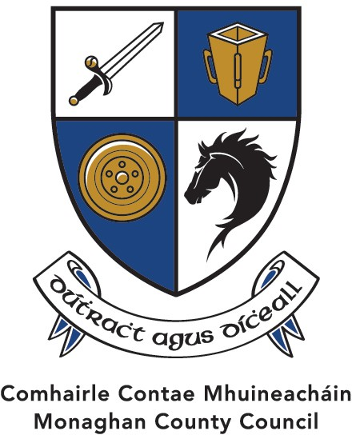
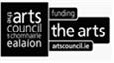
The Arts Office, The Market House, Monaghan Town, Co Monaghan, H18 R268

2025
Arts Partnership Grant /Deontas Comhpháirtíochta Ealaíon
Application & Guidelines /Treoirlínte & Iarratais
Osclaíonn sé 2 Eanáir/ Opening Date 2nd January
Sprioc Lá chun iarratas a chur isteach 4.00i.n. Dé Céadaoin 30ú Eanáir Final date to submit application Wednesday 30th January 4.00pm.
- Paying the Artist is fundamental to decisions made under this Scheme. https://www.artscouncil.ie/about/artists-pay-policy
- This Grant scheme is open to ARTS organisations, festivals, and projects that are based in Co Monaghan for 2025.
- Applicants must demonstrate a track record of achievement in the delivery of the arts in County Monaghan.
- Applicants are encouraged to apply to the Arts Council for funding. An acknowledgment from them confirming this should be submitted to us.
- The schemes’ focus is firmly placed on the Artist, public engagement and activities that have the Arts at their core.
- MCC’s Arts Framework Agreement with The Arts Council has 3 Shared Strategic Actions in its delivery, please familiarise yourself with them See 2(B) on the Application Form.
- In your application form please mark which of these 3 goals your submission might address & fulfil.
- The headings are a guide to enable the artistic quality, content, and track record to be discussed and validated by the assessment panel.
- The assessment of the artistic content within your application will be made by a panel using judgement, experience & artistic endeavour.
- Funding received from Monaghan County Council can only be used for your Artistic Programme, not administrative, utility or salary costs.
- In the panels assessment and deliberation process, it will be deemed that Funding will not be considered to submissions where at least 50% of the requested amount cannot be met.
- Successful applicants will be required to acknowledge the assistance of Monaghan County Council and The Arts Council in relation to all promotional material.
- Due to the competitive nature of this Scheme, it will not be possible to recommend funding for all eligible applicants. Eligibility and compliance with criteria for assessment alone does not guarantee that you will receive grant funding.
The total funds available under this scheme will not exceed €75K

Arts Partnership Grant Deontas Comhpháirtíochta Ealaíon
Application Form / Foirm Iarratais 2025
Fáilteofar roimh an t-iarratas seo a líonadh trí Ghaeilge

1. General Details/ Sonraí
1(a)
Name of Venue, Festival or Organisation/ Ainm an Ionaid, Féile nó Eagraíochta :
Address / Seoladh
Tel/Guthán |  | www
 |  | Email
1(b)
Contact Person/Duine Teagmhála:
Position/ Seasamh:
Are you registered with the P.P.N? An bhfuil sibh cláraithe? |  | Yes: No:
1(c)
How is your organisation constituted? (e.g., limited company)
2(a)
Please give a brief overview of your artistic aims/ Tabhair léargas gairid ar do aidhmeanna ealaíne le do thoil.
2(B) PLEASE SELECT THE GOALS WHAT WOULD BEST DESCRIBE THE OUTPUTS WITHIN YOUR
APPLICATION http://monaghan.ie/arts/arts-policy/

1. Supporting Artists: Value and Support the work of Artists and extend the range of opportunities for Artists to develop their practice.
2. Young People and the Arts: Increase opportunities for children and young people to create, access and participate in great art.
3. Creating Capacity: Investing in the professional development of venues, festivals and organisations providing high-quality arts experiences.

2(C). PROJECT PROPOSAL/ TIONSCADAL TÓGRA
outline in your narrative how your Artistic Programme and objectives might be aligned to our Strategic actions: Tabhair breac-chuntas dúinn ar do chuspóirí i gcosúil lenár ngníomhartha Straitéiseacha mar atá leagtha amach.
3(a). If you received funding from Monaghan County Council or through any of its Municipal Districts, The Arts Council, or any Statutory Government Agency in the last 3 years, please state the amount.

Year (tick as appropriate) | 2022 | 2023 | 2024
Amount | € | € | €
3(b) Supporting Documentation/ Cáipéisí Tacaíochta:

To assist in the assessment of your application, supporting documentation should be included in an email to artsoffice@monaghancoco.ie by way of a link.

Supporting Documentation | (please tick)
Tax Reference Number
Link to your Programmes/ Events (current &/or previous years)
Most recent Audited Accounts or Expenditure Details available
Associated Website/ Social Media platforms.

Monaghan County Councils Policy is to make all payments Electronically {EFT}. GDPR: The purpose for accessing your data is to process your application for the Arts Partnership Grant Scheme. The information you provide will be used by a panel in this Application Grant Scheme only. https://monaghan.ie/arts/data-protection-privacy-notice/

4. Financial Information
€
4(a) What is the estimated cost of your Arts Programme for 2025
4(b) Breakdown of Costs:
Action / Item |  | Amount - €
Programme of Events/Artistic output
Marketing/Publicity/ Advertising:
Admin & Salary Costs
Other Costs
Total |  | €

4(c). Expected Income Sources
Income Expected |  | Amount - €
Box Office
Municipal District
The Arts Council
Sponsorship
Other
Total |  | €

4(d)Funding sought from Arts Partnership Grant scheme & to be considered by Panel:

Total | €

Freedom of Information
Applicants completing this form should note that information provided to the Arts Office, Monaghan County Council may be disclosed in response to a request made under the Freedom of Information Act (1997 and 2003). Every effort will be made to protect client.
I have read and understand the Guidelines and Criteria as set out on Page 1 □ (Please Tick)

Declaration

I/We have read the award conditions/criteria, agree to be bound by them, and certify that the information in this application is correct to the best of my knowledge.

Signed: Date: Signed: Date:

This Application Form should be returned
by email to artsoffice@monaghancoco.ie
Closing date for the receipt of completed Applications is by
Thursday 30th January by 4.00pm/Dé Déardaoin 30ú Eanáir 4.00i.n.
(The Arts office will not accept Applications after the Closing Date)
Or by post to

The Arts Office, The Market House, Market Street, Monaghan, H18 R268 An Oifig Ealaíona, Teach an Mhargaidh, Sráid an Mhargaidh, Muineachán

For Office Use Only
Date Rec. | A.O. Recc. € | Co. Co. Approval
Ref. No. | Date | Date
Signed | Signed | Signed

Response Date | Payment Requested | Payment Sent/Paid
Signed | Date | Date

Successful applicants will only be paid when Monaghan County Council are satisfied that the above criteria have been fulfilled.

