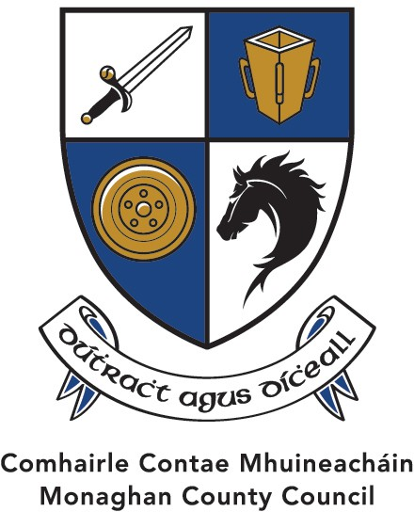
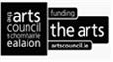
The Arts Office the Market House, Monaghan Town, Co Monaghan, H18 R268

Artist Support Scheme /Tacaíocht do Ealaíontóirí 2025
Opening Date 2nd January /Osclaíonn sé 2ú Eanáir
Deadline Thursday 30th January at 4pm /Sprioc Lá Dé Déardaoin 30ú Eanáir 4.i.n

Total Available Funds up to/ Iomlán an Chiste atá ar fáil € 18,000

Emerging Talent Established Artist

Up to 5 Awards of €600 each up to 15 Awards of €1,000 each
Monaghan County Council values and wishes to support the work of the Artist and extend the range of opportunities for artists to develop their practice. We recognise that we have a responsibility to provide ﬁnancial and other assistance to artists, so that they can be supported in the making and presentation of their work, and in their professional development.
The artist is not just the creator of art, they also encourage discourse and navigate us to think outside the box of commonly held opinions of society. They allow us to explore through their work aspects of our own lives and of the world around us. Artists are central to the development of the arts in Monaghan. (Framework agreement with Arts Council)

Guidelines
- This year’s scheme is open to any individual artist who can demonstrate their track record regardless of whether they have received funding from us in the past.
- Monaghan County Council would like to invite individual Artists to apply under this scheme and to have their application considered for funding by an independent Assessment Panel.
- The Artistic criteria will include those of you who consider yourselves Emerging talent* as well those of you who have been recognised by your peers as an Established artist**.
- Due to the competitive nature of this Scheme and the total funding available, this may limit our ability in supporting all the submissions that have merit.
- If you have been in receipt of funding from MCC under the Value-Added Scheme in the current Calendar year, your Submission will not be considered.
- If you are successful in being awarded a bursary under this scheme you may not, then seek funding under the Value-Added Scheme in the same calendar year.
https://monaghan.ie/arts/value-added-scheme-2020-2027

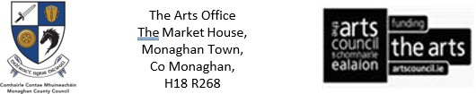

Criteria and Limits Deadline: Thursday 30th January 2025
The funding Criteria and Limits will be set under 2 headings.
1: Emerging talent *: an Artist who works in any art form medium should inform us of their current creative process of engagement with their practice will be eligible. Only twice can one be considered as an emerging talent under this Scheme.
Our aim is to award up to 5 Awards @ €600 each under this heading. This would be a recognition by MCC that you are contributing to the creative and artistic life of the County in a positive way and being rewarded as such.
2: Established Artist **: the Artist has a substantive body of work created in their career and that they have been recognised as such by your peers. This scheme is a recognition of your endeavours in your current arts practice. A one-year hiatus of being considered for funding may come into effect if you were in receipt of funding 3 years in a row, based on the number of submissions received and available funds.
Our aim is to award up to 15 Awards @ € 1,000 each under this heading this would be a recognition by MCC that your career as an Artist has contributed in a substantive way to the Artistic landscape of County Monaghan and beyond and as such should be rewarded.

Criteria
- Artists of all disciplines and those who work in any artform are welcome to apply.
- Artists must be originally from County Monaghan or reside in the County.
- Applicants in a full or part-time education programme are not eligible to apply.
- The term “Established Artist” assumes, that you have a substantive body of works created and that it has been presented to the public in any medium, and that you are recognised as such by your peers.
- The term “Emerging talent” assumes that you have presented your creative through whichever medium that best suits your creative process to the public.
- The Assessment of your Application will be made by a Panel using judgement, experience, and artistic endeavour.

Guidelines
- This Scheme will enable us to assist artists of all disciplines and in their area of creative enterprise, professional development, performance/exhibition of work and residency opportunities.
- Artists’ professional development, (e.g., further training, attendance at peer-to-peer workshops, travel grants within Ireland),
- Artists’ creation of art, (e.g., production costs, materials assistance, exploration and research assistance, residency assistance),
- Artists, their art, and the public, (e.g., performance & recording development assistance, publication & exhibition assistance, projects carried out in collaboration with county organisations)

Deadline Thursday 30th January at 4pm / Sprioc Lá Dé Déardaoin 30ú Eanáir 4.i.n
Fáilteofar roimh an t-iarratas seo a líonadh trí Ghaeilge

Ainm/ Name of Applicant:
Seoladh/ Postal Address:
Art Form/Medium which best describes your Work:
www. (Online supporting address)
Uimhir/ Contact No: Email:

Please conﬁrm that you have read the Criteria & Guidelines section.
State whether you are applying as an Emerging Talent or Established Artist

Give a concise description of your Arts Practice to assist the panel in assessing your application.

How would this Award assist you as an Artist in your creative practice?

Are you originally from Monaghan or reside in Monaghan Tick Please

Supporting Documentation
To assist the panel in Assessing your Application, all Links should reﬂect previous and current creative practice in your Submission for the past 7 years.
Please! do not Post or include any physical supporting documentation, include links to your work that best supports your case Thank you.
Le bhur dtoil! ná cuir aon breis eolas chugainn mura bhfuil sé le fáil ar line nó leis an ríomhphost GRMA

Freedom of Information
Applicants completing this Form should note that information provided to the Arts Office, Monaghan County Council, may be disclosed in response to a request made under The Freedom of Information Act (1997 and 2003). Every effort will be made to protect Client conﬁdentiality.

Declaration
I have read these award conditions/criteria, agree to be bound by them, and certify that the information to this Application is correct to the best of my knowledge.

Signed: Date:
This Application Form should be returned
by email artsoffice@monaghancoco.ie
Closing date for the receipt of completed Applications is by Thursday 30th January 2025 by 4.00pm
(The Arts Office will not accept Applications after The Closing Date) Or by post to
The Arts Office, The Market House, Market Street, Monaghan Town, H18 R268.
GDPR: The purpose for accessing your data is to process your Application for The Artist Support Scheme. The information you provide will be used by a Panel in this application for Artist Support Scheme only.

