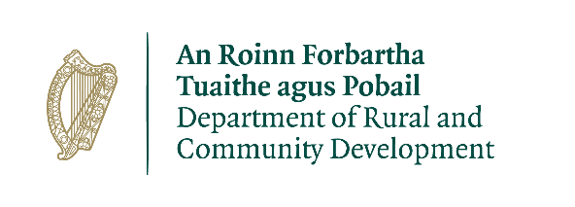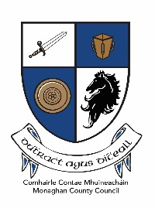

CLÁR 2018 Scheme Outline

Local Authority Measures

Background
CLÁR (Ceantair Laga Árd-Riachtanais) is a targeted investment programme for rural areas that aims to provide funding for small infrastructural projects in areas that experience disadvantage. The aim of CLÁR is to support the sustainable development of identified CLÁR areas with the aim of attracting people to live and work there. The funding works in conjunction with local/Agency and other Departmental funding programmes and on the basis of locally identified priorities.

Timelines

Scheme launch | 15th March
Applications to be received by the Department | By April 24th
Assessment and decisions, contracts | By May/June
Project Completion/Drawdown | Sept/Oct

Applications
The 2018 scheme will allow for applications to be submitted to the LA from Schools, Community Groups and also from Local Development Companies.
Applications between measures 1and 2, may be selected by the LA, providing that they are of sufficient quality and are consistent with developmental planning at a local level, LECP’s, Town plans and any other relevant plans, for onward submission to the Department for its consideration.

Applications under measure 1 may include a number of different elements (see detailed measure outline below) in respect of a single facility (school or community) up to the maximum funding limit outlined in the measure.

Please note that applications in respect of each separate facility must be submitted on a separate application form.

Application forms detailing projects in respect of multiple facilities will not be considered.

The Department will select a number of projects in whole or in part and will take the proportion of the county that is within CLÁR into account in the decision making process. Where facilities have received funding in the past, particularly under CLÁR 2017, the Department may take that into account when making final decisions regarding project selection and may prioritise those that have not received funding previously.
Applications should be submitted on the relevant application form for each measure and all relevant details should be inserted in the enclosed template also. It is important that both the application form and the template listing the projects submitted for funding, are completed correctly.
It is also important that all additional/supplementary documentation is submitted with applications.
Please Note: Where the application form or the template is not completed correctly, or where any additional/supplementary documentation is not submitted at the time of application; the application may not be considered further.
Eligible Costs
Applications should detail all of the costs associated with the proposed project and only items of a capital nature that are integral to the project should be included.

All administration costs/professional fees associated with the proposed project should be kept to a minimum and be clearly detailed on the application form. Such costs will be eligible up to a maximum of 12.5% of the overall project costs.

Grant Payment arrangements
100% after certification by the LA/LDC that the project has been completed.

Drawdown requests for payment should only be submitted to the Local Authority when the Project Promoter has itself incurred the expense. It is not acceptable that a drawdown request be submitted to Monaghan County Council if invoices etc submitted to Monaghan County Council by community groups/contractors remain unpaid.

Phase payments may be possible in limited circumstances and on a case by case basis following submission of case details to the Department.

Detailed Measures

Measure 1: Support for Schools/Community Safety Measures
CLÁR 2018 will consider support for interventions that make the school/community facility environs healthier and safer for the children attending the schools, and for children and adults using the community facilities.

In this context the table below outlines the supports eligible for funding in CLÁR areas under this measure.

Type of Intervention | Possible Funding to be allocated
Purchase and replacement of Flashing Amber Safety Lights. | Max €7,000 per set
Purchase of Child safety signs | Max €1,000 per sign
Purchase of digital speed safety signs, indicating that cars are entering a particular zone. | Max €14,000 per set
Upgrade Road markings on approach roads to Schools/community facilities. | Max €1,000
Erect pedestrian crossings in small towns and villages at schools/community facilities. | Max €22,000
Construction and upgrading of access footpaths next to schools or community facilities. | Max €30,000
Car Parking facilities to access schools or community facilities. | Max €30,000
Provision of Bus Shelters | Max €25,000
Provision of Public Lighting | Max €30,000
Overall max per project if there are a number of elements above included in applications for a single location | Max €50,000

Eligible Applicants: Schools, Community Groups, Local Development Companies, Local Authorities.

Projects proposed to Monaghan County Council/Department will be selected on the basis of:
- an application by a School/Community/LDC to the LA
- evidence that all necessary permissions are in place
- evidence where applicable that ownership/lease is in place
- full estimated costs including management/professional fees (procurement not required at this point)
- evidence that match funding is in place where relevant
- clear evidence of need, and
- relevance to the LECP/other plan.

Rate of Aid
A minimum grant of €1,000 and maximum grants as listed in the table above will apply to this measure. The scheme will provide up to 90% of the cost or the maximum amount outlined in the table above, whichever is the lesser. The remaining 10% or balance of the cost should be provided through community/other resources.

Measure 2: Schools/Community Play Areas (including Multi Use Games Areas MUGAs)
It is proposed to run a specific Play Areas measure as part of the 2018 Programme. CLÁR 2018 will consider support for the enhancement of existing and/or the development of new School/Community Play areas.

Eligible Applicants: Schools, Community Groups, Local Development Companies, Local Authorities.

The measure will be implemented via the LA’s. Projects proposed to Monaghan County Council/Department will be selected on the basis of:
- an application by a School/Community/LDC to the LA
- evidence that all necessary permissions are in place
- evidence, where applicable, that ownership/lease is in place
- full estimated costs including management/professional fees (procurement not required at this point)
- evidence that match funding is in place where relevant
- clear evidence of need, and
- relevance to the LECP/other plan.

Rate of Aid
A minimum grant of €5,000 and a maximum grant of €50,000 for projects will be available. The maximum grant payable will be 90% of the project cost or a maximum of €50,000, whichever is the lesser. The remaining 10% or balance of the cost should be provided through community/other resources.

