Monaghan County Council
is proud to support
County Monaghan Disability network & Disability Federation of Ireland
#Makewayday 2019
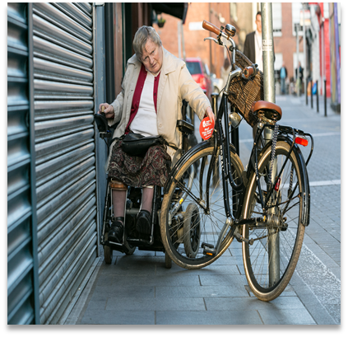

Make Way!
on our streets for people with Disabilities.
You can support Make Way Day by Joining County Monaghan Disability Network on the streets

- Monaghan town 11am Outside National Learning Network Building, The Diamond

- Carrickmacross 11am & 1.30pm CTEK Building (beside Library)

- Clones 1.30pm Outside Cairde Centre

Thursday September 26th 2019

#makewayday aims to raise awareness of the obstacles people face in public areas

