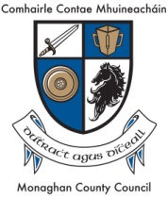
Monaghan County Council is committed to promoting and enhancing community development and increasing social inclusion activity throughout the county.

This commitment is supported by the annual Community Development Fund which invites applications from community and voluntary groups and organisations within County Monaghan. We are now inviting applications for the 2022 funding scheme.
Funding is available under the two measures outlined below:

- Measure 1: Community Infrastructure Supports
- Measure 2: Community Development Supports

Guidelines on the criteria and application forms for the Community Development Fund Scheme 2022 are available via:

- By downloading the form from www.monaghan.ie/communitydevelopment/community-development-fund-2022
- By email to cdf22@monaghancoco.ie
- By telephone Monaghan County Council, Community Development Section on 047 73750

CLOSING DATE FOR RECEIPT OF APPLICATIONS IS 4PM ON THURSDAY 25th AUGUST 2022

LATE APPLICATIONS WILL NOT BE ACCEPTED.

