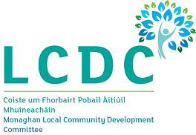

Annual Report 2022
Monaghan Local Community Development Committee

Table of contents

Introduction to Annual Report and role of LCDC Page 2
Functions of the Monaghan LCDC Page 3
Monaghan LCDC membership 2022 Page 4
LCDC meetings and presentations held in 2022 Page 5
Monaghan Local Economic and Community Plan (LECP)
and main activities of the LCDC in 2022, SICAP Programme 2022 Page 6, 7,8,
Monaghan LEADER Programme, Community Activities Fund and Peace IV Page 9, 10
Healthy Monaghan, Community Mental Health Fund Page 11
County Monaghan Map – Municipal Districts Page 12

Orla Brady, Chief Officer
Monaghan Local Community Development Committee,

Local Community Development Committee

1. Introduction to the formation of the Monaghan Local
Community Development Committee:

The governing legislation underpinning the establishment of Local Community Development Committees (LCDC) is set out in Section 36 of the Local Government Reform Act 2014 which provides for the establishment of an LCDC in each Local Authority administrative area: -

“for the purposes of developing, coordinating and implementing a coherent and integrated approach to local and community development”.
Monaghan LCDC was formed in September 2014. Monaghan LCDC is a 17-member inter-agency committee made up of statutory (8) and non-statutory (9) members with a guaranteed built in majority for non-statutory members. Monaghan LCDC’s main initial task was the development and implementation of a 6 year Local Economic and Community Plan (LECP) for the county, which was launched in 2016. The implementation of the LECP has been overseen by the LCDC and the midterm review of the Plan was conducted in 2020.
Orla Brady, Community Development Section, Monaghan County Council is Chief Officer for Monaghan LCDC. It is the Chief Officer’s role to support the development of the LCDC in line with national policy requirements and support the committee in the implementation of its role and functions.

2. The role and functions of Monaghan LCDC
The LCDC Committee:
- Has primary responsibility for co-ordinating, planning and overseeing local community development funding, whether spent by local authorities or on behalf of the State by other local development bodies.
- Brings a more joined-up approach to the implementation of local and community development programmes and interventions, pursuing an integrated approach to local community-based services across providers and delivery structures.
- Drives meaningful citizen and community engagement in the scoping, planning, delivery and evaluation of local and community development programmes;
- Pursues a more cost-efficient administration of local and community programmes and delivery structures, the matching of resources to priorities and better value-for-money in the management and delivery of programmes;
- Focuses on learning and feedback, enhancing the links between service delivery and policy development, and
- Pursues opportunities for additional funding resources for the area, whether Exchequer, EU, private or other sources.
For further information regarding the Local Community Development Committee and what it does, please contact the following.
Orla Brady LCDC Chief Officer Ann Murray, Administrative Officer
Community Development Section Community Development Section
Monaghan County Council, Monaghan County Council,
M.Tek II, M.Tek II,
Armagh Rd., Monaghan. Armagh Rd., Monaghan.
Telephone: 047 73709 Telephone: 047 73715
obrady@monaghancoco.ie amurray@monaghancoco.ie
Section 128B of the Local Government Act 2001 (inserted by Section 36 of the 2014 Act) sets out the functions of LCDCs. These functions are —

- To prepare the community elements of a 6-year Local Economic and Community Plan.

- To implement or arrange for the implementation of the community elements of the Plan.

- To review the community elements of the Plan at least once within the period of 6 calendar years and if necessary, to amend the community elements of the Plan.

- To monitor and review on an on-going basis the implementation of the community elements of the Plan and, if appropriate, to revise the actions and strategies set.

- To achieve the objectives of the community elements of the Plan,

- To co-ordinate, manage and oversee the implementation of local and community development programmes that have been approved either by the relevant local authority or by agreement between the LCDC and a relevant public authority (e.g. Government Department, State Agency)

- To seek to ensure effectiveness, consistency, co-ordination and avoidance of duplication between publicly funded local and community development programmes, in addition to pursuing co-ordination generally of all local and community development programmes within the functional area of the Committee,

- To consider and adopt a statement for consideration of the Council in respect of the economic elements of a draft of the Plan prepared by the local authority,

- To prepare an annual report on the performance of its functions.

3. Membership of Monaghan LCDC – 2022 (17 members)
Name | Statutory /  Non Statutory | Sector Represented
Gareth McMahon | Statutory 1 | On behalf of CE Monaghan County Council
Cllr. Cathy Bennett | Statutory 2 | Elected Member
Cllr. Seamus Coyle | Statutory 3 | Elected Member
Cllr. David Maxwell | Statutory 4 | Elected Member
Breege Quinn | Statutory 5 | Head of Local Enterprise Office
Deirdre Byrne | Statutory 6 | Cavan Monaghan Education and Training Board CEO
Sharon Curran | Statutory 7 | Department of Social Protection
Cathal Hand | Statutory 8 | Health Service Executive Cavan/Monaghan Area Manager
Gabriel O’Connell | Non Statutory 1 | Monaghan Integrated Development
Seamus Conlon | Non Statutory 2 | C&V Interests
Eileen Gordan Lonergan | Non Statutory 3 | C & V Interests
Brendan Lillis | Non Statutory 4 | Social Inclusion Interests
Ursula McKenna | Non Statutory 5 | Social Inclusion Interests
Alan McCabe | Non Statutory 6 | Environmental Interests
Patrick McCormick | Non Statutory 7 | Farming/Agriculture interests
Alan Johnston* | Non Statutory 8 | Business/Employer interests
Denis Sheridan | Non Statutory 9 | SIPTU Irish Congress of Trade Unions
*LCDC Chairperson
LCDC Support Staff
Orla Brady, Chief Officer, Ann Murray Administrative Officer, Olga Connolly, Staff Officer
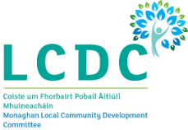

4. LCDC Meetings in 2022
The LCDC plays a co-ordinating role at county level helping to ensure that there is a coherent approach to local and community development in the county. In 2022 the LCDC met 8 times and operated effectively in managing various programmes including SICAP, LEADER, PEACE, Community Enhancement Programme, COVID Emergency Fund and the Healthy Ireland Fund.
The LCDC meet every six weeks on a Tuesday afternoon at 3pm in the M.Tek 1 Building, Monaghan. Due to the COVID 19 pandemic meetings were held online by M.S. Teams until September 2022 when a return to physical meetings resumed with Hybrid facilities also provided. A lot of credit must goes to the LCDC members in the way they embraced these new ways of doing business.

Welcome two new LCDC Members
In 2022, the Chairperson and members welcomed two new LCDC Members as follows:-

- Gareth McMahon replaced Patricia Monahan, Chief Executive Monaghan County Council.
- Breege Quinn replaced John McEntegart retired CEO Local Enterprise Office

The LCDC met eight times on the following dates:

- 18th January 2022
- 1st March 2022
- 12th April 2022
- 24th May 2022
- 12th July 2022
- 13th September 2022
- 25th October 2022
- 14th December 2022

Presentations were delivered to LCDC members on the following in 2022.
- Presentation on Peace Plus
- Presentation on preparation of LECP 2022-2027 and LECP Actions 2016-2021
- Presentation on Social Enterprise – Truagh Development Association
- Equality Sub Committee Presentation
- Presentation on Healthy Ireland Round 4 2023-2025
- Presentation on SICAP 2018-2023

LOCAL ECONOMIC AND COMMUNITY PLAN 2016-2021 (LECP) and LECP 2022-2027

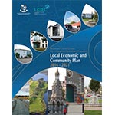
LOCAL ECONOMIC AND COMMUNITY PLAN (LECP)2016-2021 and LOCAL ECONOMIC AND COMMUNITY PLAN (LECP) 2023-2027

In 2022 the LCDC received guidelines from the Department to commence the process of preparing a new six year Local Economic and Community Plan for the years 2023-2027.

Monaghan LCDC and Monaghan County Council carried out a review of the previous Monaghan Local Economic and Community Plan for 2016-2021 to identify what had worked well and what could be improved. The new plan will build on the lessons learned from the previous LECP cycle, as well as reflecting the needs of communities as we emerge from the Pandemic. A full review of the 66 Community actions and the 61 Economic actions contained in the 2016-2021 Plan was carried out in 2022.
66 Community Actions | 5 to start | 8 Ongoing | 53 Complete
61 Economic Actions | 4 to start | 5 Ongoing | 52 Complete

The findings from the review will inform the development of the new LECP 2023-2027.

The review of LECP 2016-2021 took place in 2022 and it transpired that the environment in which Monaghan County Council was operating in 2022 was much changed from when the Local Economic and Community Plan was published in 2016.

5. Main activities of the LCDC in 2022

SOCIAL INCLUSION COMMUNITY ACTIVATION PROGRAMME (SICAP)
The objective of SICAP, delivered by Monaghan Integrated Development CLG and overseen by the LCDC, is to provide social inclusion support to disadvantaged individuals and groups throughout the county. The 2022 budget for SICAP in Monaghan was €683,136. An additional budget of €53,080 was provided to support the Ukraine refugees who arrived in county Monaghan. The programme targets for 2022 were to assist 34 groups and 300 individuals. Mid-year and End of Year reviews of the programme took place in 2022 and all targets set under the programme were either reached or exceeded.

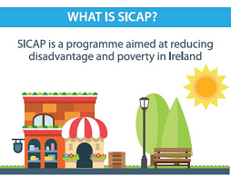
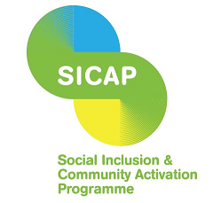

Goal 1 - Local Community Groups

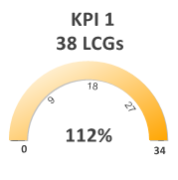
Under KPI 1 the target set under Goal 1 – Local Community Groups was to assist 34 groups, and this was exceeded at 38 Groups.

Number of LCGs (KPI 1) Interventions by support type

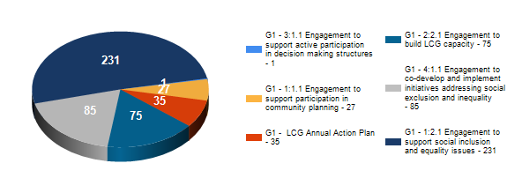

Percentage of LCGs (KPI 1) by Primary and Secondary Target Group
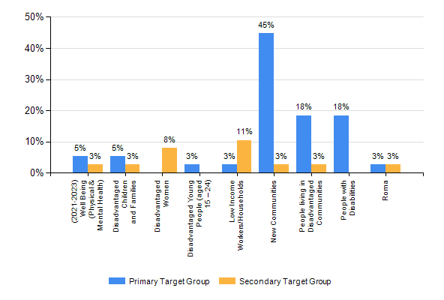

Goal 1 - Social Enterprises

  Total SE grants:
  €1,536.00
  13
  Social Enterprises
  supported
  0
  Jobs created

Goal 2 – Individuals

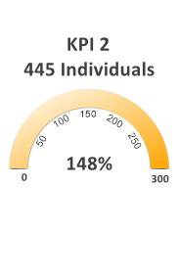
Goal 2 Individuals
Supports here focused on personal development and wellbeing and progression towards training that leads back to education or employment. Under KPI 2 the target set was 300 and this was exceeded at 445. (Lot 34-1 = County Monaghan)

KPI 2 living in disadvantaged areas by Pobal HP Deprivation range

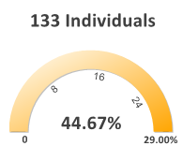
HP Deprivation Range | No. of Individuals (KPI 2)
Disadvantaged | 108
Very disadvantaged | 25
Extremely disadvantaged | 0
Total disadvantaged | 133

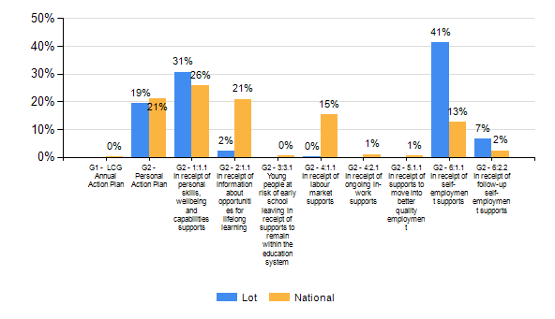

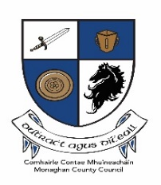
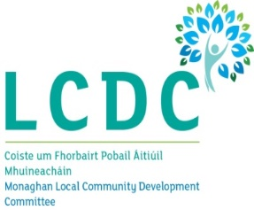

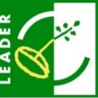
MONAGHAN LEADER Programme 2014-2022
In December 2022, Monaghan County Council received confirmation from the Department that the LEADER Programme 2014-2022 was extended to end of August 2023. Monaghan LCDC is the Local Action Group (LAG) and is the decision maker in respect of project applications. Monaghan Integrated Development CLG (MID) is the implementing partner and Monaghan County Council is the Financial Partner for the Programme. The LAG met 9 times in 2022 and approved projects recommended by the IEC members, and approved extensions to projects. Monaghan LEADER aims to develop sustainable rural communities throughout the county, by promoting social inclusion, economic development and stimulating Enterprise, Tourism, and Community Services while protecting the natural and built heritage of the county. The funding was awarded based on a Local Development Strategy (LDS) for Monaghan which sets out the priority areas for the programme.
€6,872,946.94 was the total allocation for the LEADER Programme 2014-2022 for County Monaghan. Since the start of the current LEADER Programme, 132 projects have been allocated funding.
During 2022, Monaghan LAG approved 16 projects across County Monaghan to the value of €695,873.13 and this exhausted all of the remaining funding. Also in 2022, the entire European Union Recovery Instrument (EURI) budget allocated to the County of €517,685.25 was allocated benefitting a further 8 projects across County Monaghan.
Examples of LEADER Projects funded:-

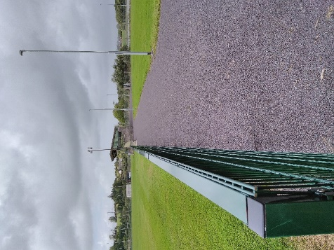
Cremartin Shamrocks GFC received LEADER grant funding of €66,518.71 (75% rate of aid) under the Social Inclusion theme to develop an approx. 800m tarmacked walking track around their football field, along with a tarmacked all weather area for exercise activities. The track is accessible to wheelchair users and buggies.

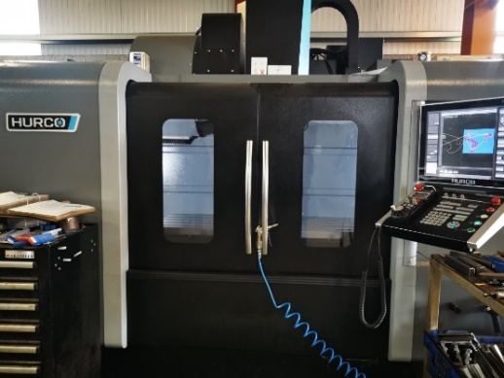
Finn Precision Engineering Ltd received LEADER funding under the Enterprise Development theme to purchase a 3-axis high speed machining centre to meet the increasing demand. They were approved grant funding of €61,683 (75% rate of aid).

New LEADER Programme 2023-2027
In October 2022, Minister Humphreys announced a new LEADER Programme for 2023-2027, Interested groups were invited to apply to deliver the new Programme. The selection process to be conducted over two stages; the first stage is an ‘Expression of Interest’ by eligible groups followed by a more detailed stage which will see them develop their LEADER Development Strategies or LDS. €6m was awarded to County Monaghan for the new LEADER Programme for 2023-2027 from Department of Rural and Community Development.

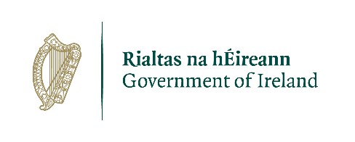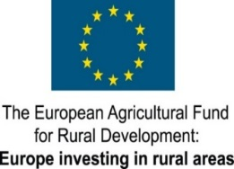
Community Activities Fund
Funding of €265,142 was awarded by the Department of Rural and Community Development
to County Monaghan for the Community Activities Fund. 102 projects received funding towards running costs and capital projects. The fund was administered by Monaghan Local Community Development Committee (LCDC).

The Community Activities Fund supported groups, particularly in disadvantaged areas, with their non-pay running/operating costs, as well as funding to carry out necessary repairs and improvements to their facilities and purchase equipment.

Peace IV
The Peace IV local action plan covered 3 themes, Children and Young People, Shared Spaces and Services and Building Positive Relations, and was developed and delivered by Monaghan LCDC Peace IV Partnership Board. The board was made up of representatives from Monaghan County Council, Monaghan County Childcare Committee, Cavan Monaghan ETB, Monaghan Integrated Development, Youth Network, Minority Faith Communities, Ethnic Minorities, Public Participation Network, Women’s Network, Ex-Prisoner Groups, Clones Erne East Sports Partnership and members of the Monaghan Local Community Development Committee (LCDC).
€3,038,567.96 was awarded by the Special EU Programmes Body (SEUPB) to deliver on activities to achieve the outcomes in the action plan.
During 2022, the Peace IV local action plan concluded activity in County Monaghan with the completion of a new Multi Use Games Area at Mullaghmatt.
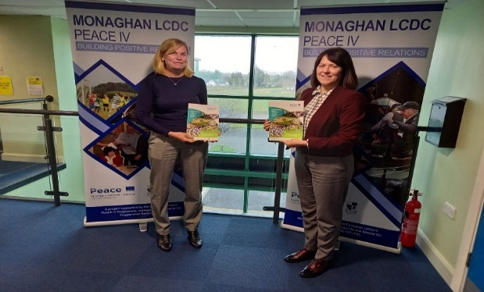
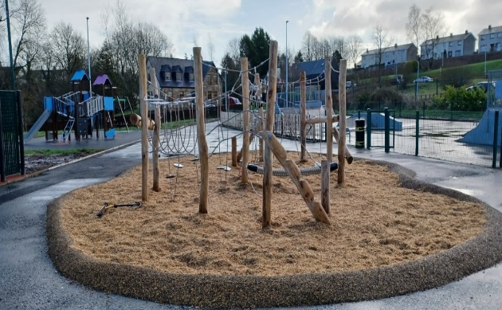

To complete the closure of the programme, and to celebrate the success of the activities delivered through the programme, a booklet was produced of case studies and photos from all project activity Monaghan LCDC Peace IV Closing Booklet.

Healthy Monaghan
Round 3 of the Healthy Ireland Fund ended in 2022. An extension of 3 months had been granted by Pobal as a response to the difficulties experienced by all Healthy Ireland counties during 2021. As a result, the deadline for all programme activity to be completed by was changed from the 31st December 2021 to the 31st March 2022.

The lead partners under this round included The Peace Link, HSE, Monaghan Sports Partnership, Monaghan Integrated Development, Foroige, and Ballybay-Clones Municipal District. All partners successfully completed their activities by this date.

Work commenced on planning for Round 4 of Healthy Ireland Funding. Consultations and research to inform a new Healthy Monaghan Fund Strategy 2023-2025 commenced from October 2022.

Community Mental Health Fund
Twelve local community and voluntary groups received funding to deliver mental health activities in their communities. Due to COVID there was an extension of this funding into 2022 and all activities were delivered on. CYPSC in partnership with ISPCC continued to deliver a mental health service in South Monaghan in 2022.

Map of County Monaghan showing 3 Municipal Districts

