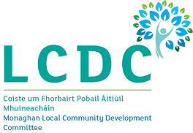

Annual Report 2023
Monaghan Local Community Development Committee

Table of contents

Introduction to Annual Report and role of LCDC Page 2
Functions of the Monaghan LCDC Page 3
Monaghan LCDC membership 2023 Page 4
LCDC meetings and presentations held in 2023 Page 5
Monaghan Local Economic and Community Plan (LECP)
and main activities of the LCDC in 2023, SICAP Programme 2023 Page 6, 7,8,
Monaghan LEADER Programme, Community Activities Fund and Peace IV Page 9, 10
Healthy Monaghan, Community Mental Health Fund Page 11
County Monaghan Map – Municipal Districts Page 12

Nicola Payne, Chief Officer
Monaghan Local Community Development Committee,

Local Community Development Committee

1. Introduction to the formation of the Monaghan Local
Community Development Committee:

The governing legislation underpinning the establishment of Local Community Development Committees (LCDC) is set out in Section 36 of the Local Government Reform Act 2014 which provides for the establishment of an LCDC in each Local Authority administrative area: -

“for the purposes of developing, coordinating and implementing a coherent and integrated approach to local and community development”.
Monaghan LCDC was formed in September 2014. Monaghan LCDC is a 17-member inter-agency committee made up of statutory (8) and non-statutory (9) members with a guaranteed built in majority for non-statutory members. Monaghan LCDC’s main initial task was the development and implementation of a 6 year Local Economic and Community Plan (LECP) for the county, which was launched in 2016. The implementation of the LECP has been overseen by the LCDC and the midterm review of the Plan was conducted in 2020.
Nicola Payne, Community Development Section, Monaghan County Council is Chief Officer for Monaghan LCDC. It is the Chief Officer’s role to support the development of the LCDC in line with national policy requirements and support the committee in the implementation of its role and functions.

2. The role and functions of Monaghan LCDC
The LCDC Committee:
- Has primary responsibility for co-ordinating, planning and overseeing local community development funding, whether spent by local authorities or on behalf of the State by other local development bodies.
- Brings a more joined-up approach to the implementation of local and community development programmes and interventions, pursuing an integrated approach to local community-based services across providers and delivery structures.
- Drives meaningful citizen and community engagement in the scoping, planning, delivery and evaluation of local and community development programmes;
- Pursues a more cost-efficient administration of local and community programmes and delivery structures, the matching of resources to priorities and better value-for-money in the management and delivery of programmes;
- Focuses on learning and feedback, enhancing the links between service delivery and policy development, and
- Pursues opportunities for additional funding resources for the area, whether Exchequer, EU, private or other sources.
For further information regarding the Local Community Development Committee and what it does, please contact the following.
Nicola Payne LCDC Chief Officer Leona Keenan, Administrative Officer
Community Development Section Community Development Section
Monaghan County Council, Monaghan County Council,
M.Tek II, M.Tek II,
Armagh Rd., Monaghan. Armagh Rd., Monaghan.
npayne@monaghancoco.ie lmcdonal@monaghancoco.ie
Section 128B of the Local Government Act 2001 (inserted by Section 36 of the 2014 Act) sets out the functions of LCDCs. These functions are —

- To prepare the community elements of a 6-year Local Economic and Community Plan.

- To implement or arrange for the implementation of the community elements of the Plan.

- To review the community elements of the Plan at least once within the period of 6 calendar years and if necessary, to amend the community elements of the Plan.

- To monitor and review on an on-going basis the implementation of the community elements of the Plan and, if appropriate, to revise the actions and strategies set.

- To achieve the objectives of the community elements of the Plan,

- To co-ordinate, manage and oversee the implementation of local and community development programmes that have been approved either by the relevant local authority or by agreement between the LCDC and a relevant public authority (e.g. Government Department, State Agency)

- To seek to ensure effectiveness, consistency, co-ordination and avoidance of duplication between publicly funded local and community development programmes, in addition to pursuing co-ordination generally of all local and community development programmes within the functional area of the Committee,

- To consider and adopt a statement for consideration of the Council in respect of the economic elements of a draft of the Plan prepared by the local authority,

- To prepare an annual report on the performance of its functions.

3. Membership of Monaghan LCDC – 2023 (17 members)
Name | Statutory /  Non Statutory | Sector Represented
Gareth McMahon | Statutory 1 | On behalf of CE Monaghan County Council
Cllr. Cathy Bennett | Statutory 2 | Elected Member
Cllr. Seamus Coyle | Statutory 3 | Elected Member
Cllr. David Maxwell | Statutory 4 | Elected Member
Breege Quinn | Statutory 5 | Head of Local Enterprise Office
Deirdre Byrne | Statutory 6 | Cavan Monaghan Education and Training Board CEO
Sharon Curran | Statutory 7 | Department of Social Protection
Cathal Hand | Statutory 8 | Health Service Executive Cavan/Monaghan Area Manager
Gabriel O’Connell | Non Statutory 1 | Monaghan Integrated Development
Seamus Conlon | Non Statutory 2 | C&V Interests
Eileen Gordan Lonergan | Non Statutory 3 | C & V Interests
Brendan Lillis | Non Statutory 4 | Social Inclusion Interests
Ursula McKenna | Non Statutory 5 | Social Inclusion Interests
Alan McCabe | Non Statutory 6 | Environmental Interests
Patrick McCormick | Non Statutory 7 | Farming/Agriculture interests
Alan Johnston* | Non Statutory 8 | Business/Employer interests
Denis Sheridan | Non Statutory 9 | SIPTU Irish Congress of Trade Unions
*LCDC Chairperson
LCDC Support Staff
Nicola Payne Chief Officer, Fiona McEntee Administrative Officer, Olga McConnon Staff Officer
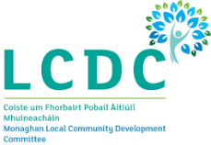

4. LCDC Meetings in 2023
The LCDC plays a co-ordinating role at county level helping to ensure that there is a coherent approach to local and community development in the county. In 2023, the LCDC met 8 times and operated effectively in managing various programmes including SICAP, LEADER, PEACE, Community Support Fund, Community Recognition Fund and the Healthy Ireland Fund.
The LCDC usually meet every six weeks on a Tuesday afternoon at 3pm in the M. Tek 1 Building, Monaghan with Hybrid facilities provided.

Welcome New LCDC Members

In 2023, the Chairperson and members welcomed new LCDC Members as follows:-

- Gareth McMahon replaced Patricia Monahan, Chief Executive Monaghan County Council.
- Breege Quinn replaced John McEntegart retired CEO Local Enterprise Office
- Eilin Connolly replaced Breege Quinn Local Enterprise Office
- Packie Kelly replaced Eileen Gordon Lonergan as a PPN Representative

The LCDC met eight times on the following dates:

- 24th January 2023
- 7th March 2023
- 25th April 2023
- 23rd May 2023
- 11th July 2023
- 12th September 2023
- 24th October 2023
- 5th December 2023

Presentations were delivered to LCDC members on the following in 2023

- Presentation on Parenting Monaghan
- Presentation on LECP 2023-2027
- Presentation on the Preparation of the Peace Plus Local Action Plan
- Presentation on Preparation of the Monaghan County Development Plan 2025-2031
- Presentation on Monaghan Migrant Integration Strategy

Local Economic and Community Plan (LECP) 2023 - 2028

Following extensive consultation throughout 2023, the final draft of LECP was presented to the LCDC. The plan will be officially launched in 2024.

5. Main activities of the LCDC in 2023

The objective of SICAP, delivered by Monaghan Integrated Development CLG and overseen by the LCDC, is to provide social inclusion support to disadvantaged individuals and groups throughout the county. The 2023 budget for SICAP in Monaghan was €788,468.00. This included additional budget to support the Ukraine refugees who arrived in county Monaghan. The programme targets for 2023 were to assist 34 groups and 300 individuals. Mid-year and End of Year reviews of the programme took place in 2023 and all targets set under the programme were either reached or exceeded.

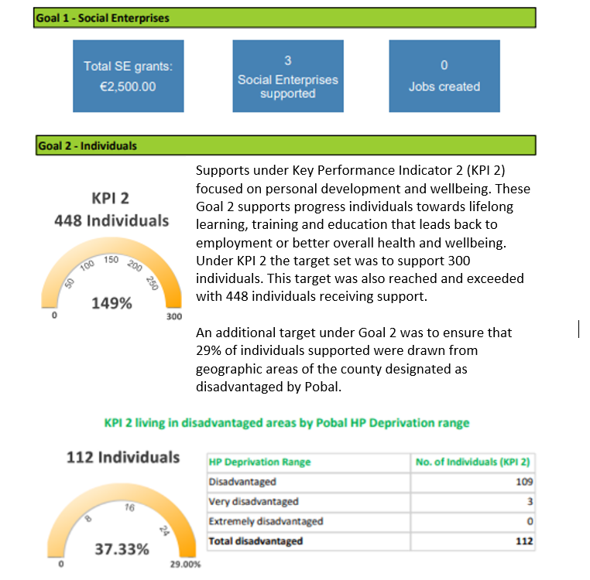

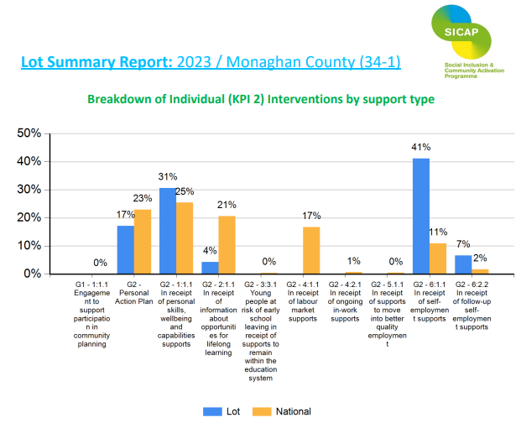

MONAGHAN LEADER Programme 2014-2022
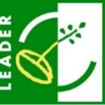
Monaghan LEADER aims to develop sustainable rural communities throughout the county, by promoting social inclusion, economic development and stimulating Enterprise, Tourism, and Community Services while protecting the natural and built heritage of the county. The funding was awarded based on a Local Development Strategy for County Monaghan which sets out the priority areas for the programme. Monaghan LCDC is the Local Action Group (LAG) and is the decision maker in respect of project applications. Monaghan Integrated Development CLG (MID) is the implementing partner and Monaghan County Council is the Financial Partner for the Programme. The LAG met 8 times in 2023 and approved projects recommended by the IEC members, and approved amendment and extension deadlines for projects.
€6,872,946.94 was the total allocation for the LEADER Programme 2014-2022 for County Monaghan, which is supporting 134 projects. With all funds allocated in 2022, a small amount returned to the budget in 2023 through decommittals which was reallocated to two small projects. All the European Union Recovery Instrument (EURI) budget of €517,685 was already allocated back in 2022 to 8 projects across the County. A further €397,361 was also allocated to projects under the LEADER Co-operation measure and €48,605 under the LEADER Food Initiative throughout the duration of the programme. LEADER 2014-2022 is now closed, and promoters have until the end of March 2024 to drawdown any remaining funds.

Examples of LEADER Projects funded:-
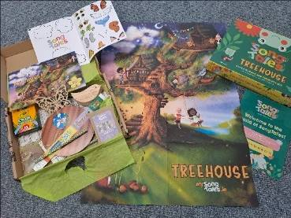
Ceol Connected Ltd received €26,643.75 (75% rate of aid) to hire a branding agency to create a robust brand identity and strategy for their SongTales, which is a new high-quality music and creativity box service for children ages 3-7 years. The project also included the services of a visual artist to research, develop and design the activities for the SongTales boxes. Included also in the project was the purchase of theatre lighting for the company’s live productions, workshops, and festival events to ensure consistency in lighting quality and versatility for their lighting designs.
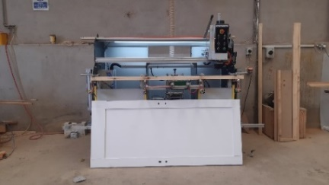
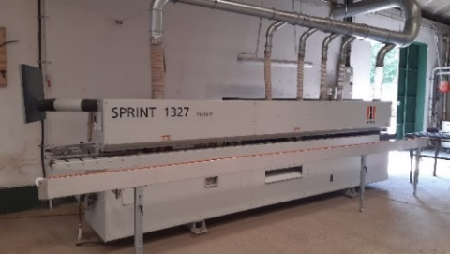
Kelly Brothers Ltd based in Mullaghmatt have concentrated their business on the production of specialised bespoke fire doors and fire door sets. Their existing machinery for producing solid joinery did not lend itself to the efficient production of veneered fire doors resulting in inefficiencies in labour, materials, and other costs. Kelly’s set out to purchase more modern machinery to achieve a better workflow, decreasing lead-time and downtime, with a view to increasing sales, profitability and reducing waste. They received €74,640 (75% rate of aid) under EURI funding to purchase an edge bander, which applies solid hardwood lipping to the edge of the door core at the same time as trimming the ends and reduces the timber lip to the thickness of the core.
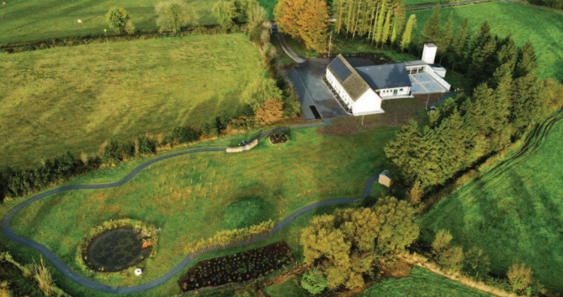
Tydavnet Group Water Scheme is serving drinking water supplies to some 1,000 domestic dwellings and 350 farm enterprises. They purchased Knocknagrave National School (closed in 2009), and have transformed it, along with its playing field, into an Environmental Education Centre and Biodiversity Hub. The Centre aims to facilitate school visits, the wider community, rural groups, and farming in understanding the vital necessity to adjust to the many changes we must all make in our everyday living experiences, if the urgency of the recent climate change legislation requirements are to be met. The Centre provides education supports, including interactive videos, to explore nature and learn of the harmful impacts of climate change and the loss of biodiversity on all our lives. The inter-connecting theme is drinking water and the absolute need to protect water sources and their larger catchments for pollution threats etc. The new Centre has been renovated to a high environmental standard with great emphasis on alternative renewable energy. The promoter received LEADER funding of €38,508.27 to part-fund the development of the biodiversity garden/hub and €200,000 for the reconstruction and renovation of the old school into a visitor/environmental interpretative centre.

Community Activities Fund

Funding of €265,142 was awarded by the Department of Rural and Community Development
to County Monaghan for the Community Activities Fund. 102 projects received funding towards running costs and capital projects. The fund was administered by Monaghan Local Community Development Committee (LCDC).

The Community Activities Fund supported groups, particularly in disadvantaged areas, with their non-pay running/operating costs, as well as funding to carry out necessary repairs and improvements to their facilities and purchase equipment.

Peace Plus
Monaghan County Council have been awarded an indicative allocation of €4.5 million to deliver on actions in the Local Peace Plus Action Plan. During 2023, the Monaghan LCDC Peace Partnership Board met to develop the Local Peace Plus Action Plan, and to complete the associated application form for submission to SEUPB. Several public consultation events were held to identify needs and priorities for inclusion in the plan. The application deadline is 28th March 2024, and it is anticipated that project activity will commence early 2025.

Healthy Monaghan
The Healthy Ireland Strategic Action Plan 2023-2025 for County Monaghan provides a roadmap towards good health, access to services, healthy environments and the promotion of resilience. The Healthy Ireland Framework required each county to prioritise two outcomes based on local needs. As a result of extensive consultation with various stakeholders, community representatives and the Healthy Monaghan Steering Committee, the Healthy Monaghan programme identified the outcome indicators as below:
- increase in % of adults and children meeting physical activity guidelines.

- decrease in the number of people showing negative mental using the five item Mental Health Index-5(MHI-5) from the RAND SF-36 questionnaire.

The Healthy Ireland Fund 2023-2025 Local Strategy for County Monaghan was approved by the LCDC in January 2023. In May 2023, the Healthy Monaghan Programme was awarded €228,698.32 under the Healthy Ireland Programme 2023 -2025 Round 4 funding. Various initiatives were approved for the 2023 programme with some carrying over activities to 2024. Two initiatives received funding in 2023 and will continue to receive funding in 2024 and 2025. These initiatives are:
- Foroige, Early Intervention Youth Mental Health Service, under the decreasing negative mental health outcome.
- CMETB, Planet Youth – Increase Leisure Time Initiative, under the increasing physical activity outcome.

Community Support Fund

A total of €281,485.79 was paid out to 130 community and voluntary organisations under the Community Support Fund in 2023. The funding was supplied by the Department of Rural and Community Development and was managed locally by Monaghan Local Community Development Committee. Both capital and operational costs were eligible for consideration under the programme, and a percentage of the Fund was ringfenced to support women’s groups.
Minister for Rural and Community Development, Heather Humphreys announced at a community event in Doohamlet Community centre, the successful grantees.
Community Recognition Fund

Minister for Rural and Community Development, Heather Humphreys and Minister of State Joe O’Brien announced on 24 January 2023 details on the Community Recognition Fund 2023.

The fund aimed to support the development of community infrastructure and facilities in recognition of the contribution being made by communities across the country in welcoming and hosting significant numbers of new arrivals from Ukraine and other countries. Monaghan County Council received an allocation of €881,203, of which 5% was allocated to Admin/Technical cost, €44,060.15 leaving a balance of €837,142.85 for projects.

Monaghan County Council sought Expressions of Interest from community groups through the PPN while also actively looking at projects to be considered for submission under the scheme.

The following projects were submitted to the Department of Rural and Community Development for consideration and subsequently approved.

Town/Village | Proposal | Funding Allocated
Monaghan | Playpark extension at Rossmore Forest Park | €150,000
Monaghan | Belgium Park Refurbishment | €121,857
Monaghan | Provision of Outdoor Handball Area at Monaghan Harps | €7,190
Carrickmacross | Construction of Bandstand and ancillary works adjacent to Civic Offices, Carrickmacross | €143,010
Carrickmacross | Provision of sensory garden/play area and outdoor educational space, including the upgrade of existing gravel pathways, to enhance existing recreational amenities at Cloughvalley. | €136,037
Ballybay | Refurbishment & Enhancement of Ballybay Town Park | €120,000
Clones | Upgrade & development of bus stop at 98 Avenue | €120,000
Clones | Provision of Outdoor exercise equipment for children at The Peace Link clones | €39,047

Map of County Monaghan showing 3 Municipal Districts

