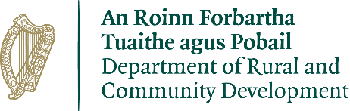
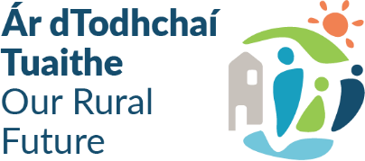
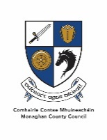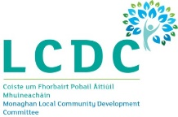
Community Recognition Fund 2024
Window III Call
This funding is specifically targeted at projects that are located in communities, towns and villages that are hosting the Beneficiaries of Temporary Protection and/or International Protection Applicants (‘new arrivals’) including towns identified for the rapid build homes programme. The Fund aims to support the development of facilities that will be used in the future by all members of the community. It is separate in its objectives and scope to any other public funding streams which aim to support the development of public service needs arising from the significant number of arrivals from Ukraine and other countries.

The proposal must demonstrate that the funding is targeted at, and specifically invested in, those communities, villages and towns where the highest level of new arrivals are located and where there is a clear need for investment identified. In Monaghan the areas with the highest number of new arrivals from Ukraine and other countries are: Monaghan, Carrickmacross, Clones and Ballybay.

Projects situated in areas that do not have high levels of new arrivals will not be eligible for funding under the Community Recognition Fund 2024.

Type of projects eligible for funding are:
- development, enhancement or refurbishment of community or cultural facilities including play areas, walkways, parks, community/sensory gardens, allotments, and recreational areas;
- development, enhancement or refurbishment of local club and sports facilities including facilities such as community swimming pools, changing rooms, toilets, digital aids such as score / information boards etc.;
- enhancement to school/parish facilities which are open to use by all of the community after school hours;
- purchase of equipment for local clubs, festivals, community events and organisations e.g. music, arts or sports equipment;
- transport infrastructure such as the purchase of community vehicles, bus shelters and attendant information boards; (any vehicle funded must be in good condition and not more than 5 years old)
- projects that help address dereliction and/or wider local economic and community development objectives;
- purchase and refurbishment of vacant or derelict buildings for community use where a clear need is identified.
- Purchase of land and associated works for the development of community facilities such as play areas/ MUGAs or town parks/ community gardens, recreational areas etc. (purchases must only be administered by the local authority).

The minimum level of funding for an individual project is €50,000 with a maximum of €500,000 applying.
Monaghan County Council is now seeking Expressions of Interest for projects under the Community Recognition Fund 2024 – Window III.

If you have a proposed project that is suitable for submission under the Community Recognition Fund and demonstrates the ability to be of benefit to the wider community, can be completed within the required timeframes and is within the identified areas, further information can be downloaded from Monaghan County Council’s website https://monaghan.ie/communitydevelopment/grants-funding-schemes/
Please contact Aisling Kierans, Community Development Section at akierans@monaghancoco.ie or on 047 73707 to discuss potential projects for submission to this scheme as early as possible.

As in previous years, applications will be assessed on a competitive basis.

Please ensure that you have fully completed the application form and all supporting documentation is included before submitting.

All Expressions of Interest applications should be received no later than 4.00 p.m. on Monday 16th December 2024 by email to crf@monaghancoco.ie

Late application’s will not be considered after the closing date.

