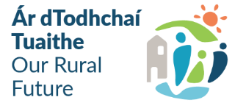

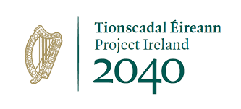

OUTDOOR RECREATION INFRASTRUCTURE SCHEME 2024/2025
Project Development Measure – Expression of Interest Form
Local Community Information
Community Group:
Contact Person:
Position:
Email:
Telephone No.:
List all other stakeholders involved in this application:

Project Information
Project Name:
Please provide a clear and concise description of the proposed project:
This will be used for the Press Release, if approved, max. 30 words
Has this project, or part of, previously received funding under ORIS?
Location of proposed project:
Please provide the Eircode and/or XY (ITM format) Coordinates of the project: XY coordinates should be captured in Irish Transverse Mercator (ITM) formats. Coordinates can be converted to ITM format here: https://gnss.osi.ie/new-converter/. This data will be used to geo-map all successful projects |  |  | EIRCODE  XY (ITM)
  E |  |  |  |  |  |  |  | N
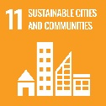
Outline the steps taken to ensure that the proposed locations and projects have been identified in consultation with relevant communities and in particular in consultation with the local residents, local Community Response Fora, LCDC, LDCs and any other stakeholders.
List events that facilitated this consultation e.g. Town-Hall meetings, advertisement, local media, social media, consultation with elected representatives, PPN’s, resident’s associations etc.

Please confirm if planning consents e.g. planning permission/Part 8 planning consent are all in place at time of application. Please provide planning reference number and expiry date (if applicable):
If planning permission is not required, please advise why:
Has consultation with landowners taken place?
If project traverses Coillte lands or within 200m of NPWS lands, a letter or consent/support should be included with the application
Please provide a synopsis of the proposal, detailing the intervention envisaged and the works proposed. Include a summary of the Measure 2/3 project that will be developed as a result of the completion of the Project Development proposal:

Outline how the proposed final project supports outdoor recreation:



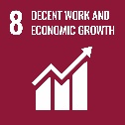

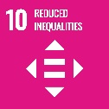
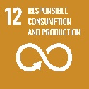
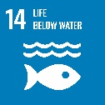
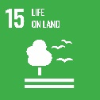

How will the final project support tourism in the local area:

Outline how the proposed final project is strategic in nature:

Detailed Costings for Proposed Project:
Please provide detailed breakdown of all elements of the proposed works:
Project Elements*  (provide details of each element) | Cost (inc. VAT)
 | €
 | €
 | €
 | €
 | €
 | €
 | €
 | €
Local authority costs (if applicable)
1. | €
2. | €
3. | €
4. | €
Total Project Cost (sum of project elements costs) | €
Grant Aid amount sought  (Max of 90% of total project costs) | €
Match Funding: (Min 10% of total cost) | €
Match Funding supplied by (LA/LDC/Community/Philanthropic)

Please provide as much details as possible as how you arrived at these costs

*Failure to provide adequate detail and costings will result in the project receiving lower marks

Your application must include:

- Fully completed Application Form – incomplete applications may not be considered.
- Up-to-date Bank or Credit Union Account Statement as evidence of match funding.
- Proof of Ownership/Title if any of the works are on privately owned land.
- Written consent of Landowners.
- Proof of Planning Permission or any other required approvals.
- Breakdown of Total Estimated Project Costs (minimum of 2 quotes)

Timelines:
Projects funded under the Project Development Measure should be completed within 18 months of approval. It is expected that these projects will be approved in Q2 2025.

Please provide an indicative time frame for completion of the project:
 | Proposed date: | Indicative time frame (days/weeks):
Commencement date:
Completion date:

Use of Data
The information on this Application Form will be used by the Department of Rural and Community Development for the purposes of processing the application. Further information may be sought by the Department to clarify aspects of the project proposal. The application form will be shared with Fáilte Ireland for assessment purposes. The Department may draw on broader, more specialist expertise where required, and such information as considered necessary to complete an assessment of your application may be shared with those experts

The Applicant and the Department are subject to the data protection and privacy laws of Ireland and the EU, in particular the Data Protection Act 2018 and Regulation (EU) 2016/679, known as the EU General Data Protection Regulation (“GDPR”). Any personal information which you provide as part of the application process will be obtained and processed in compliance with Data Protection legislation.
The Department retains the right to disclose for the purposes of a request under the Freedom of Information Act 2014 or otherwise, in connection with the funded project(s) –
- any information supplied by the Applicant to the Department,
- any relevant data gathered by the Department in administering grant aid to the project, except where the information is considered to be personal or commercially sensitive.

Declaration by Lead Applicant
I confirm that I have read and understood this document and declare that the particulars supplied in this application are true and correct and that –
- This project is eligible under the ORIS criteria.
- The costings are accurate and reasonable.
- Match funding is available for the project.
- Evidence of ownership (if applicable) or the consent of the landowner.
- The project will comply with Public Procurement Guidelines.
- The project conforms to the LECP and other local or regional plans.
- No funding has been allocated for the same works from any other sources.

Proof of the above is not required at the time of application but must be available to the Department or its agents on request.

I acknowledge the information regarding the use of data set out above and give consent to the Department of Rural and Community Development for the sharing of all information, personal or otherwise, contained in this application and any attachments accompanying it, in accordance with the uses of the data and information provided above.

Signed on behalf of _______________________ (Lead Applicant Organisation)

Signature _______________________________

Name in Block Capitals_____________________

Position_________________________________

Date___________________________________

All completed Expressions of Interest under Project Development Measure must be submitted in WORD Format to oris@monaghancoco.ie by 4.00 p.m. on Tuesday 17th December 2024. All application will be subject to a competitive selection process.
Expressions of Interest received after this date and time will not be considered for the 2024/2025 Outdoor Recreation Infrastructure Scheme.

