Department of Rural and Community Development
Local Enhancement Programme 2025

Applications under the €1m Current Funding

NOTE: Closing Date Friday 31st January at 5pm
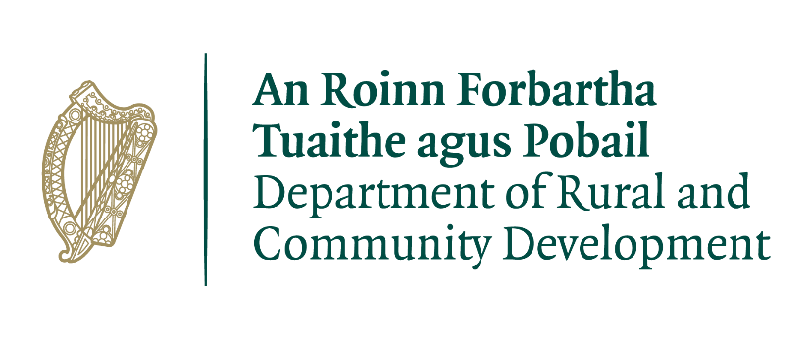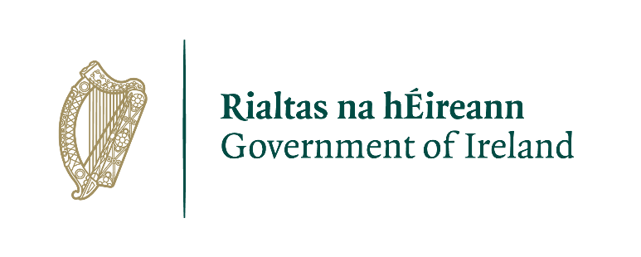
FOR OFFICE USE ONLY

Date Received:

Reference Number:

LCDC recommendation:

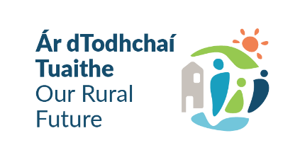

Group/Organisation Name:

Please use the ONLINE APPLICATION FORM to make your application. Go to www.monaghan.ie and click the ‘community grants’ button to access the online application portal
Applications will be accepted by email or post if you are unable to make an online application.
ALL APPLICATIONS ARE TO BE RETURNED
By Friday 31st January 2025 at 5pm
By email to: communitygrants@monaghancoco.ie
By post to: LCDC, Monaghan County Council, MTEK II, Knockaconny, Armagh Road, Monaghan H18 YH59

CLOSING DATE WILL BE STRICTLY ADHERED TO

Please read and make yourself familiar with the Application Guidelines for the ‘Local Enhancement Programme 2025’ before completing this form.

Department of Rural and Community Development
Local Enhancement Programme 2025
€ 1m Current Funding

The Department of Rural and Community Development (“the Department”) has allocated funding of €1 million to support groups/organisations across Ireland.

This is a reserved fund under the Local Enhancement Programme 2025. The application process is being administered by Local Community Development Committees (LCDCs).

Applications for this funding can be made on this application form. Community Groups/Organisations are eligible to apply, once they meet the LCDC’s qualifying criteria.

It envisaged that this funding would, in general, be allocated in a relatively equal manner across Community Groups/Organisations that submit valid applications.

TERMS AND CONDITIONS

- The €1million funding under the Local Enhancement Programme will support Community groups/organisations particularly in disadvantaged areas, to support their non-pay running costs for example energy costs/bills (electricity costs, refuse charges, heating charges), rental/lease costs, insurance bills.
- This is a current funding scheme. The scheme does not provide funding for capital works, equipment etc. This can be applied for under the capital allocation of the funding.
- The information supplied by the applicant Community Group/Organisation must be accurate and complete.
- Inaccurate or incomplete information may lead to disqualification and/or the repayment of any grant made.
- All information provided in respect of the application for a grant will be held electronically. The Department reserves the right to publish a list of all grants awarded on its website.
- The Freedom of Information Act applies to all records held by the Department and Local Authorities, including applications received and any additional correspondence related to the application.
- The application must be signed by the Chairperson, Secretary or Treasurer of the organisation making the application.
- It is the responsibility of each organisation to ensure that it has proper procedures and policies in place including appropriate insurance where relevant.
- Applications must be on the application form for 2025.
- Evidence of expenditure, receipts /invoices must be retained and provided to the LCDC, the Department of Rural and Community Development, the relevant local authority or any agent acting on their behalf if requested.
- Grant monies must be expended and drawn down from the LCDC by 31st December 2025.
- The Department of Rural and Community Development’s contribution must be publicly acknowledged in all materials associated with the purpose of the grant.
- Generally, no third party or intermediary applications will be considered.
- Late applications will not be considered.
- To ensure appropriate monitoring and governance, the Department is stating that only operating/running costs related to this period are eligible - 1st June 2024 to 30th May 2025
- Applications by post should use the correct value of postage stamps and allow sufficient time to ensure delivery not later than the closing date of 31st January 2025. Claims that any application form has been lost or delayed in the post will not be considered, unless applicants have a Post Office Certificate of Posting in support of such claims.
- Breaches of the terms and conditions of the grants scheme may result in sanctions including disbarment from future grant applications.
- Please ensure the application form is completed in full. Incomplete applications will not be considered for funding.
- In order to process your application, it may be necessary for Monaghan County Council to collect personal data from you. Such information will be processed in line with the Local Authority’s privacy statement which is available to view on www.monaghan.ie.

SECTION 1 – YOUR ORGANISATION

Name of Group/Organisation

Address

Eircode

Contact name

Role in Group

Telephone number

E-mail

Website

Alternative Contact name

Alternative Telephone number

Alternative E-mail

Successful applications for funding under this programme will only be paid to the applicant organisation’s Bank Account. Please ensure you have your Bank Account details to hand if your application is successful.

Charitable Status Number (if applicable): ___________________________________________

Tax Reference Number (if applicable): _____________________________________________

Tax Clearance Access Number (if applicable): _______________________________________
Section 2: Description of Activities

Please provide a description of your Organisation/Group including information on the number of members, the organisational structure of your group, your group’s aims, whether there is any criteria for membership, the main focus of the activities of your group, etc.

SECTION 3 – Project Details

What will the funding be used for?

Amount being applied for: | €
Is this amount the partial or total cost of the purchase of non-pay running cost(s) where support is being applied for: | ☐Partial | ☐Total
If partial, please give the estimated total cost: | €

Please list each bill below

Payee | Date | Amount
(you can add more if needed)

Important note: You MUST include supporting documentation for EACH bill you are claiming for. Please attach a copy of each bill, plus proof of payment (ie bank statements, till receipts). If you need assistance with you application please contact the Community Dept on 047 73720 or communitygrants@monaghancoco.ie for information on the required supporting documentation.

Please state how your group/organisation proposes to acknowledge the Department, LA or LCDC.

Note: Depending on the amount being applied for, this could be as simple as including an acknowledgement on notices/signs, or in any newsletters that are being produced locally.

SECTION 4 - DECLARATION

- I declare that the information given in this form is correct.

- I confirm I have read and fully understand the Terms and Conditions of this Programme (see page 2-3 of this form).

- I confirm that this grant application is submitted in acceptance of and compliance with the Terms and Conditions.

- I confirm that the group/organisation does not have the funding to cover the costs without this grant aid or alternatively that with the grant the Group will now cover a larger cost which they otherwise would not be able to afford.
- I confirm that the applicant Group is tax compliant (if tax registered).

Name in block capitals (on behalf group/organisation):

Signature:

Position held (block capitals):
Date:

The Department operates the Local Enhancement Programme through the Local Community Development Committees (LCDCs). It is a grant programme that provides funding to enhance facilities in disadvantaged areas. The Department is committed to funding of €7 million for this programme. The €1 million current funding is part of the €7 million funding.

