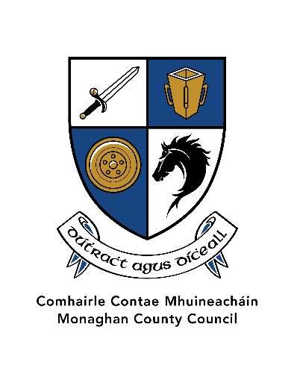
Monaghan County Council

2. Community Development Fund 2025
Application Form
If you need any assistance completing your application or have any queries, please contact Community Development Section by email: communityfund@monaghancoco.ie or at 047 73720.
Please note that one quote is required to be submitted for each aspect of the project.
Section One: General Information
Community Group Name & Address
Contact Person
Contact Number
Email
Address for correspondence
Which Municipal District will your project be located in. | Monaghan MD  Carrickmacross/Castleblayney MD  Ballybay/Clones MD
Section Two: Project Details

Give a brief description of your group.
Give a brief description of the project for which you are seeking funding?
Proposed timescale of the project in 2025?
Assessment Criteria
How many people will your project benefit, and in what way?
Tell us how you intend to deliver this project. Does your group have the capacity to deliver it?
Does your project offer good value for money? How?
How does your project promote social inclusion, participation and/ or resilience?
How does your project help prepare your community for climate change?

Breakdown of Costs:  (Please submit one quote for each element of the works)
  Description of costs | Amount
  Total
Amount requested from Monaghan County Council | €
Tax Reference Number
Tax Clearance Access Number
Section Four: |   Eligibility checklist Please tick
- Is your group registered with Monaghan Public Participation Network? | Yes     | No
- Did your group receive any funding from Monaghan County Council in the last two years? If Yes, please provide details: | Yes    | No
- If you answered yes to question number 2, have you submitted an up to date expenditure report in respect of this funding? | Yes   | No
- Have you attached quote(s) for each aspect of the project? (Please note that failure to submit quotes will render your application invalid). | Yes | No

Declaration
- I declare that the information given in this form is correct.

- I confirm I have read and fully understand the Community Development Fund Scheme 2025 prior to completing this form.

- I confirm that the event will be appropriately insured and that all Health & Safety legal obligations will be met.

- For events planned for the public realm, I can confirm that I have liaised with the relevant Municipal District Office and permission is in place.

- I confirm that the application is being submitted by a not-for-profit community or voluntary group.

- I confirm that the applicant group/organisation is tax compliant (if tax registered).

Name in block capitals (on behalf of group / organisation):
Signature:
(Typed signature is acceptable)
Position held in group / organisation (block capitals):
Date:

Completed application forms and one quote should be returned to:
communityfund@monaghancoco.ie

Closing date for receipt of applications is 4pm on Friday 21st February 2025.
Late applications will not be accepted.
Details of our Data Subject Notification and Privacy Notice may be found on www.monaghan.ie/corporateservices/data-protection/

