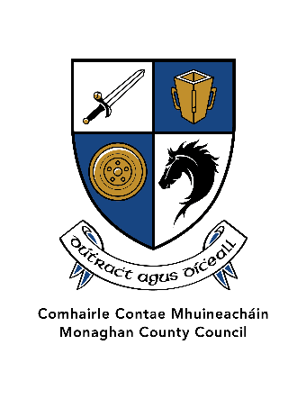

2. Community Development Fund Scheme 2025
Closing Date for Applications – Friday 21st February 2025 at 4pm
Details of our Data Subject Notification and Privacy Notice may be found on
www.monaghan.ie/communitydevelopment/grants-funding-schemes/
- Introduction
The Community Development Fund aims to promote and enhance community development and increase social inclusion activity throughout the county. This funding scheme, through the provision of small-scale financial grants, will support the invaluable work of local community and voluntary groups in County Monaghan.
- Who may apply?
- Any not-for-profit community or voluntary group who provide services and activities within County Monaghan.
- Applicants are advised to register with the Monaghan Public Participation Network.
You can register your group at www.ppnmonaghan.ie or by emailing ppn@monaghancoco.ie If you are registered and wish to find out your PPN number you can do so at the PPN website or at Registered Groups - PPN Monaghan.
- Important information
- Groups are welcome to make one application under the Community Development Fund. The maximum grant available to each community group is €3,000. Groups must demonstrate that they have the resources available to fund projects which cost in excess of this amount. Details of additional resources available must be included in the application.
- Monaghan County Council will endeavour to ensure funding is distributed equally throughout the county. Funding will be distributed on a competitive basis and all applications will be subject to a scoring process which is detailed below.
- If your group received funding under any previous scheme, please ensure that your funding has been spent and fully drawn down. Receipt of completed expenditure reports for funding previously awarded by Monaghan County Council is essential and only applications that have submitted this will be considered.
- Projects must be fully completed by 31st December 2025. Failure to complete projects during this timeframe may mean that future applications for funding are not considered.
- Groups must comply with all relevant Health & Safety legislation, where required.
- Failure to complete funded projects within the timeframe may result in a request for the funds to be returned.

- Eligible Projects
The fund endeavours to support local communities to promote and encourage community participation and engagement throughout the county.
Applications will only be accepted from not-for-profit or voluntary groups. Eligible projects include:
- Community development activities, programmes and events.
- Training, promotional activities and publications.
- Equipment such as laptops, defibrillators, tablets etc.
- Not for profit festivals and community events that provide a positive benefit to communities in Monaghan.
- Projects which have included positive Climate Change Actions.
- Projects that promote inclusiveness, for example those that support a diverse range of users, for example projects which include people with disabilities, older adults, marginalised groups etc.
- The funding may be used to help reduce the community contribution on a project of significant scale, where the main funding source is either an EU or Irish government programme. This applies to projects which have been approved in 2025 and which the spend will occur before the end of 2025.
The maximum grant payable is €3,000
One up to date verbal quote must be submitted with all applications for supplies or services valued at less than €1,500, and at least two written quotes for supplies or services in excess of €1,500 so that they can be considered as per below:
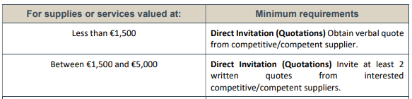
- Ineligible Applications
- Applications from individuals, commercial organisations and for-profit organisations.
- Applications for small scale capital works such as kitchen facilities, toilets, meeting rooms, repainting or renovations of Community Centres etc. are ineligible. Improvements to play/recreation spaces and parks are also ineligible.
- Applications from community organisations based outside county Monaghan, including national organisations.
- Applications from Community groups (and their affiliates) in receipt of annual funding from Monaghan County Council.
- Applications for funding will not be considered where a more appropriate source of funding is available e.g., Sports Capital Fund or the Sports Partnership Funding.
- Applications for the purchase of buildings or land (or costs associated with same).
- General appeals towards overall costs of a project.
- Applications for running costs of projects (wages, electricity etc.).
- Applications for servicing of debt or retrospective funding.
- Applications where the activities fall under the remit of another Government Department.
- Applications from groups that were previously funded but failed to provide expenditure reports.
- Applications from groups who have failed to complete projects under previous funding schemes.
6. Selection Process
- All applications eligible under the criteria will be individually assessed against the guidelines of the scheme.
- Priority will be given to applicants who demonstrate the greatest benefit.
- Final decisions on all applications will be made by Monaghan County Council.
- Match funding is not a requirement of the scheme.

A minimum scoring of 50% of the marks available must be achieved in each category in order to qualify.
Monaghan County Council will conduct evaluations of applications submitted based on the following criteria:
- Quality
- Capacity
- Value for Money
- Social Inclusion
- Contribution to Climate Change Adaption

In the interest of transparency please see details of the Marking Scheme which will be used to assess all valid applications received below:

Criterion | Maximum Mark Possible | Mark allocated
Quality  - Relevance to the scheme  - Reach: e.g., number of attendees  - Impact on community | 30
Capacity  - Track Record  - Capacity to deliver project | 20
Value for money  - Link between funding/costs and deliverables & benefit to community | 30
Social Inclusion  - Projects which promote inclusion, participation and resilience. | 10
Contribution to Climate Change Adaption  - Projects which promote sustainability and have a positive environmental impact. | 10
Total Marks | 100

- How to Apply
- The application can be submitted online at www.monaghan.ie/communitydevelopment/grants-funding-schemes/ where guidelines and applications forms are also available.
- Please ensure that you have read the guidelines carefully and ensure that your project is eligible for funding.
- Please ensure that you apply using the correct application form.
- Please complete all questions in the application form.
- Support is available from staff in the Community Development Section for any groups wishing to make an application by emailing communityfund@monaghancoco.ie or by telephone at 047 73720.
- Please submit completed application form/s before the advertised closing date.
- Closing date for receipt of applications is 4pm on Friday 21st February 2025. Late applications will not be accepted.
- Acceptance of Offer
- Successful applicants will be required to sign the Letter of Offer, which will constitute a contract with agreed objectives, targets, timescale and costs.
- The contract is conditional on the applicant complying with Tax Clearance procedures.
- An Expenditure Report must be forwarded to Monaghan County Council within four weeks of completion of the project. It must include receipts for agreed expenditure to at least the value of the grant awarded.
- Monaghan County Council may carry out a site inspection to ascertain that all work has been carried out as per the Letter of Offer.

Completed application forms should be returned to:
communityfund@monaghancoco.ie
Closing date: 4pm on Friday 21st February 2025

For further details, including application forms, please see:
www.monaghan.ie/communitydevelopment/grants-funding-schemes/

