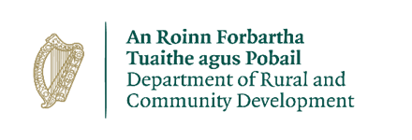
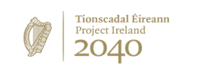
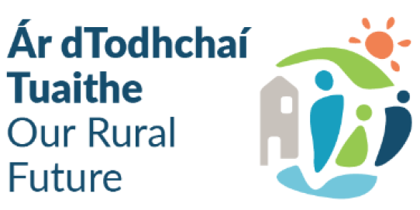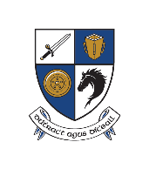
Expression of Interest Form
Town & Village Renewal Scheme 2025
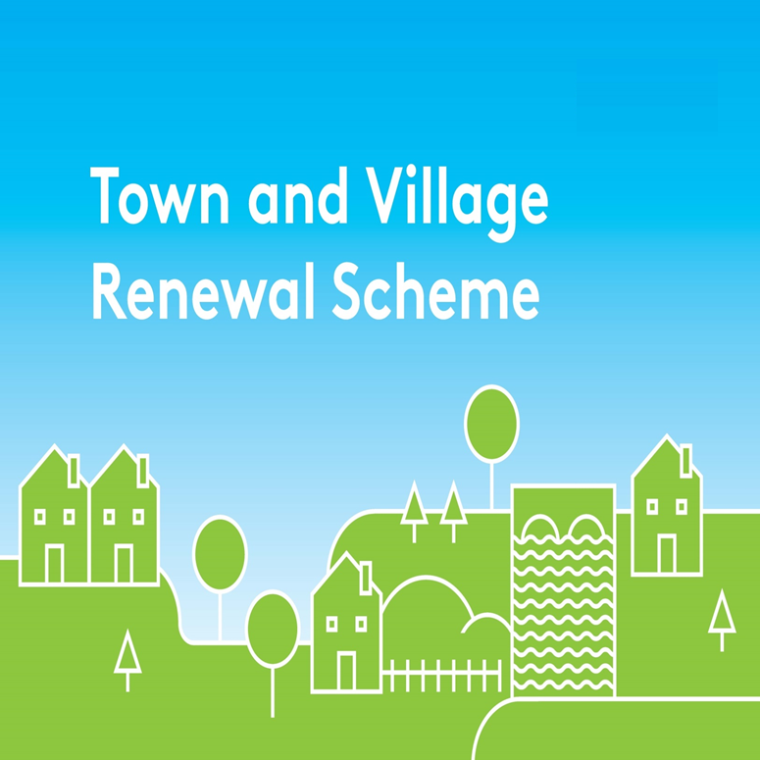
Please complete this Expression of Interest form
and return it to your Local Authority designated contact.

Town & Village Renewal Scheme 2025

Town/Village covered:

Please indicate which category of funding is being applied for:

Category 1 Category 2 Category 3

Towns/Villages with Towns/Villages with Towns/Villages with

Population of 5,000 Population of Population up to

or less 5,001-10,000 15,000

Funding Option (please tick): Main Scheme Project Development Measure

Amount of Funding Requested:

Applicant Group:

Applicant Contact Name:

Applicant Contact Address:

Applicant Telephone Number:

Applicant Mobile Number:

Applicant Email Address:

- Has funding for this project ever been sought from other sources? Yes No
(If "YES" yes please specify from what source and if funding was provided)

- Who are the specific project stakeholders/community partners in this project?
(Chamber of Commerce, Community group, etc.).

- Project details (including costs):
- If seeking funding of between €300,000 and €500,000, please detail the particular case for this level of funding.

- What is the objective of the proposed project and how will the intended outcomes be measured? (Please identify any metrics or benchmarks that will be applied).

DECLARATION
I hereby confirm that I have read and understand this document. I request that consideration be given in support of the project as outlined above.

Signature __________________________________________________

Position __________________________________________________

Date __________________________________________________

