Monaghan Holy Well information form
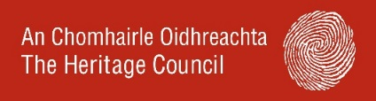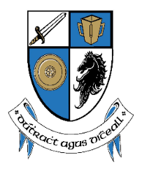

Name of well: | Dedication (ie. Saint): | Townland/ address of well:
Location: (please describe where it is or include a map or grid reference). | Description and setting: (is it in a field, alongside a road, part of a grotto etc):
Do you know what day the well was visited and what prayers were said? |  | Were offerings left at the well, stone or at a nearby tree?
Are there customs, rounds, traditions, stories or cures associated with your local holy well that you would like to share?

Is the well under threat from changes in usage or development?

If you want to please include your name and a contact detail (so we can respond to you with queries or updates about this specific project): | Contact – email / phone number: | THANK YOU FROM MONAGHAN COUNTY COUNCIL HERITAGE OFFICE  heritage@monaghancoco.ie
For full details of the collection, processing and sharing of your personal data and your rights in this regard, please view the Council’s full Privacy Notice on our Website www.monaghan.ie

