APPLICATION FOR SOCIAL HOUSING – UPDATE OF DETAILS
- Please complete the following form to update your application for social housing with Monaghan County Council.
- Documents needed to update your application are listed below. Please send in the relevant documents with this form.
- If you have any questions, please call the Housing Department on tel: 047 30502.
- Please post your update form and the required documents to Monaghan County Council, Housing Dept, Council Offices, The Glen, Monaghan OR bring the form into the office in person.
DOCUMENTS REQUIRED
- These may apply to you if your circumstances have changed recently/since you applied or since you last updated your information with the Council.
- The council may need you to submit further documentation and will tell you about this as quickly as possible if needed.
For all households | - Proof of current address (e.g. a bill, copy of tenancy agreement)
Any new household members (e.g. new babies) | - Birth Certificate
Any recent Marriages or Civil Partnerships | - Marriage/Civil Partnership certificate
Any household member in employment | - Latest P60  - The last 6 payslips
Any household member in self-employment | - 2 years of accounts
Any household members in receipt of social welfare | - Information from the Department of Social Protection on current social welfare payments (payment names and amounts)
Any household member who is a non-EEA national | - A copy of the latest GNIB card  - A copy of the latest Stamp endorsement on the passport
Any recent legal separation or divorce | - Copy of the agreement
Any recent custody arrangement | - Document which sets out the arrangements
Any recent maintenance arrangements | - Document which sets out how much maintenance is received
PROCESSING DETAILS

Are you still interested in receiving Social Housing? (tick) | 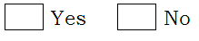

Comhairle Contae Mhuineacháin
Monaghan County Council

- Your details (please write in the following or tick where indicated)
Full name
PPS No.
Email address
Phone number
Civil status (please tick) | 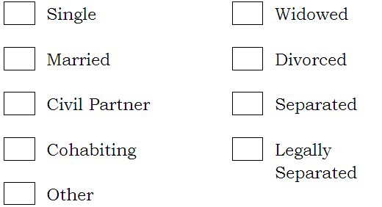
Employment status (please tick the box which applies to you)
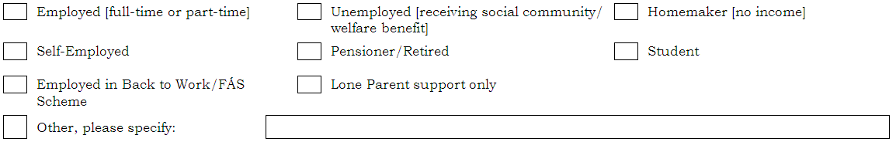

- Joint Applicant details (please write in the following or tick where indicated)
Name of joint applicant
PPS No.
Relationship to yourself e.g. partner, spouse.
Civil status of Joint Applicant
(please tick)
Employment status (please tick the box which applies to the Joint Applicant)

- Income details (please fill out the following about WEEKLY income for you and the Joint Applicant)
Income types (per week) | You | Joint Applicant
Employment income | € | €
Self – employment income | € | €
Social welfare income | € | €
Social Welfare payments
(please write in names of the payments received e.g Job Seeker’s Allowance)
Maintenance received | € | €
Any other income | € | €
Other income type
(Please write in where
any other income is from)

- Details of any children/dependents or anyone else to be included on the application(please write in the following or tick where indicated)
Name (1)
Date of Birth
PPS No.
Employment/Education status (please tick the box which applies to this person)
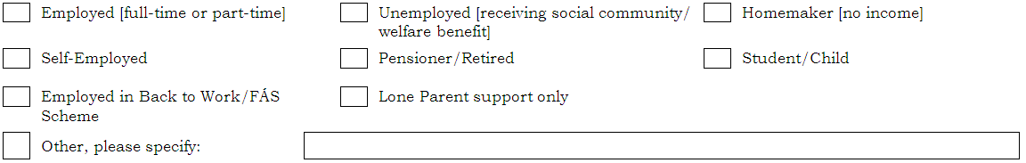
Their weekly income (If over 18) | €

Name (2)
Date of Birth
PPS No.
Employment/Education status (please tick the box which applies to this person)
Their weekly income (If over 18) | €

Name (3)
Date of Birth
PPS No.
Employment/Education status (please tick the box which applies to this person)
Their weekly income (If over 18) | €

Name (4)
Date of Birth
PPS No.
Employment/Education status (please tick the box which applies to this person)
Their weekly income (If over 18) | €

- Disability and/or Medical Information
Does anyone in the household have a disability or medical condition? | Person’s name _____________________________
Please describe the disability or medical condition
If someone in the household has a disability, please indicate if the disability falls into any of the following categories (you may tick more than one)
- Intellectual disability
- Mental health disability
- Physical disability
- Sensory disability
Due to the disability or medical condition are there any particular requirements needed in a home? (please tick)
If so, please describe
the particular requirements
(E.g. wheelchair access needed)

- Traveller specific accommodation
Do you require Traveller specific accommodation? (please tick)

- Where the household lives (please write in the following or tick where indicated)
Current address
(please write in)
Last previous address before this
(please write in)
Where do you live now?
(please tick the box which best describes your current living arrangement)
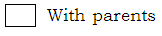 | 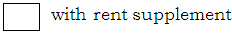  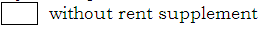
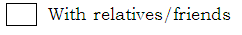
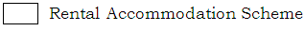 | 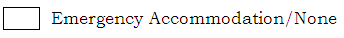
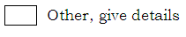___________________________________________________________________
If you are renting, please write in when your tenancy started or when you moved in (dd/mm/yy)
Landlord’s name
Landlord’s phone number
How much rent do you pay a month or week? |  |  | €
How much rent supplement do you get each week (if any)? |  |  | €
What type of accommodation do you live in at present?
(please tick the box below which describes your current accommodation)
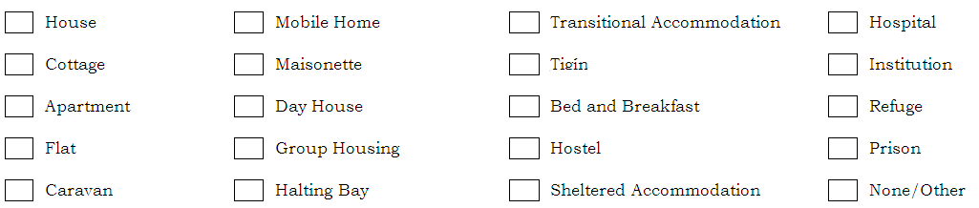
What facilities do you have in your current accommodation? (please tick the boxes which apply)
How many bedrooms are there in your current property?
(please write in number)
Do you share some rooms with another household i.e. persons not on this form? (please tick)
If so, please write in what rooms you have to share.

- Other property/land (please write in the following or tick where indicated)
Do you or any member of the household own property or land in Ireland or any other country? (please tick)
If so, does this include a residential property which is vacant?
Address of the property or land owned (please write in)

- Basis for Application to Monaghan Local Authority
Please indicate the basis for your application to Monaghan Local Authority as follows: [only one box should be ticked]

Household is normally resident in the housing authority area.

OR

Household has a local connection with the housing authority area.

Please specify the nature of the local connection:

OR

The housing authority should consider the application for social housing support for the following reason[s]:

- Areas of Choice (area preferences for housing)
Please update your ‘Areas of Choice’ on page 7 by ticking the areas you are interested in, subject to the following rules –
- you can only pick a maximum of 3 Areas of Choice
- you must pick the area you are currently residing in as per basis of application above
- you can indicate a maximum of 2 more from the list on page 7
- If you select a new Area of Choice to that previously selected, you must submit evidence of your connection to the new Area of Choice.
Emyvale Monaghan Castleblayney

Glaslough

Carrickroe (OPD’s Only)
Ballinode Clones Carrickmacross

Scotstown

Knockatallon

Tyholland
Smithboro

Newbliss

Scotshouse

Rockcorry

Threemilehouse

Annyalla

Ballybay

Bawn

Latton

Oram

Doohamlet

Inniskeen

Magheracloone

DECLARATION
Once you have finished filling out this form in full, please read this declaration carefully and sign and date it when you are satisfied that you understand it.
Collection and Use of Data
The housing authority will use the data which you have supplied to administer your housing application. Data may be shared with other public bodies for the purpose of the prevention or detection of fraud. The housing authority may, in conjunction with the Department of the Environment, Community & Local Government, process this data for research purposes including forward planning in relation to the assessment of housing needs.
The housing authority may, for the purpose of its functions under the Housing Acts of 1966 - 2009, request and obtain information from another housing authority, the Criminal Assets Bureau, An Garda Síochána, The Department for Social Protection, the Health Service Executive [HSE] or an approved housing body, in relation to occupants or prospective occupants of, or applicants for, local authority housing, and any other person the authority considers may be engaged in anti-social behaviour.

Monaghan County Council is compliant with Data Protection Legislation including the provisions of the Data Protection Act 2018 and GDPR. A copy of the Privacy Statement can be provided if you request it in writing from the Housing Office, Monaghan County Council, Glen Road, Monaghan. Tel 04730500.

Declaration
I/We declare that the information and particulars given by me/us on this form are true and correct.
I/We undertake to notify the housing authority of any change in my/our household circumstances (e.g. address, household composition, employment, medical conditions etc.)
I/We also authorise the housing authority to make whatever enquiries it considers necessary to verify details on my/our application.

Signature of Main Applicant
Print full name (BLOCK CAPITALS please)
Signature of Joint Applicant
Print full name (BLOCK CAPITALS please)
Date (dd/mm/yy)
-

