Body Matters, Hygiene, Health & Illness

This selection of titles looks at a range of body matters from Brushing your teeth to Where Babies Come from, as well as a range of common illnesses your child may suffer from.

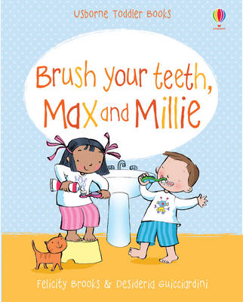 | Brush Your Teeth, Max and Millie - by Felicity Brooks  This is a delightful new title for the very young, with simple stories teaching good habits.  This charming story follows two young friends, Max and Millie, as they learn about the simple concept of brushing their teeth, so children can learn from their example. Simple, repetitive text makes this title easy and enjoyable to read to very young children.
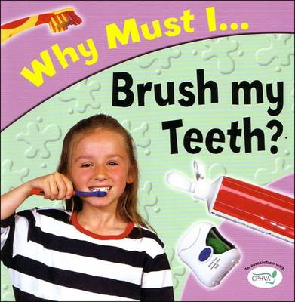 | Why must I brush my teeth?  - By Jackie Gaff  "The Why Must I" series explains to young children the importance of taking care of themselves and their bodies.  "Why Must I Brush my Teeth?" includes a simple, step-by-step guide to tooth brushing and flossing, as well as explaining wobbly teeth, tooth decay and describing a trip to the dentist.
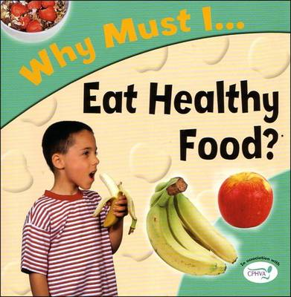 | Why Must I Eat Healthy Food?  - Jackie Gaff  "Why Must I Eat Healthy Food?" sets out the importance of a healthy and balanced diet, the reasons for avoiding too much sugar and fat, and gives a simple explanation of the digestive system.  "The Why Must I" series explains to young children the importance of taking care of themselves and their bodies.
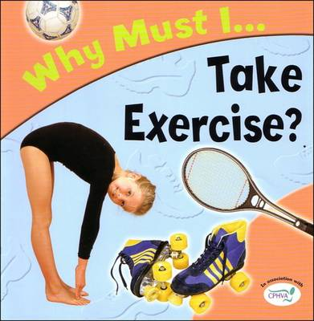 | Why Must I Take Exercise?  - Jackie Gaff  This book explains the link between exercise and health, fitness and wellbeing, and includes a number of simple exercises that children can do themselves.  It also contains a list of further resources which you can use to look at the topic further with your child.
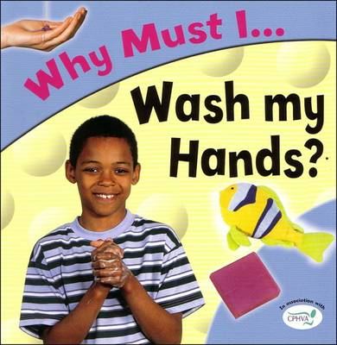 | Why Must I Wash My Hands?  - Jackie Gaff  "Why Must I Wash My Hands?" takes a lively look at the importance of keeping your whole body clean, as well as explaining how soap works, and why germs are harmful.  It takes into account things like Pet Care, Kitchen Safety and Cuts and Grazes
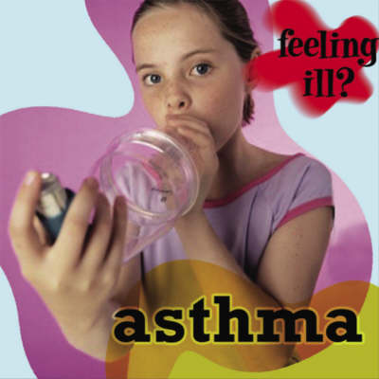 | Asthma (Feeling ill?)  - Jillian Powell  "Feeling ill?" is a new and exciting series for very young readers about common childhood illnesses and diseases.  This title focuses on Asthma, what causes it, Asthma Medicine and living with Asthma.
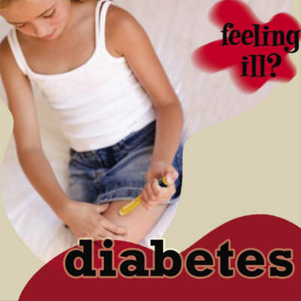 | Diabetes (Feeling ill?)  - Jillian Powell  "Feeling ill?" is a new and exciting series for very young readers about common childhood illnesses and diseases.  This title looks at diabetes, insulin injections, blood sugar tests, diet & diabetes and check-ups.
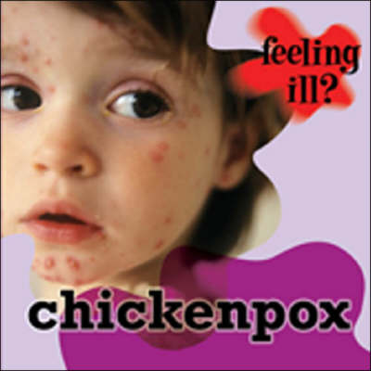 | Chickenpox (Feeling ill?)  - Jillian Powell  "Feeling ill?" is a new and exciting series for very young readers about common childhood illnesses and diseases.  This title explores Chickenpox, how you catch it, the rash, treatment and getting better.
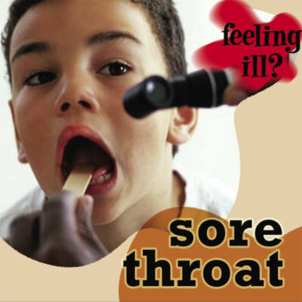 | Sore Throat (Feeling ill?)  - Jillian Powell  "Feeling ill?" is a new and exciting series for very young readers about common childhood illnesses and diseases.  Sore Throats are common among Children. You can use this book to look at what causes sore throats, strep throat and tonsillitis.
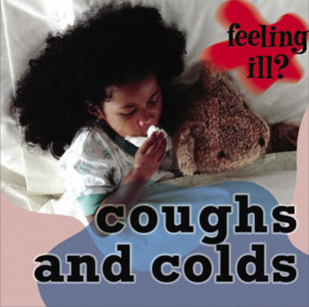 | Coughs and Colds (Feeling ill?)  - Jillian Powell  "Feeling ill?" is a new and exciting series for very young readers about common childhood illnesses and diseases.  This title looks at catching a cold, fighting a cold, getting better, Colds and Hygiene.
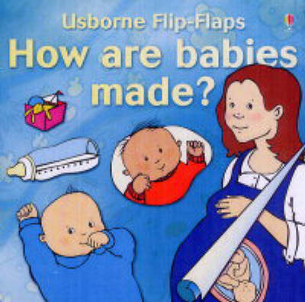 | How are babies made? (Flip-Flaps)  - Alastair Smith  Combining simple text and illustrations, this book from the Usborne Flip Flaps series explains to young children how a baby forms inside its mother.  Lift the flaps on the pages to see the baby changing as it grows…and grows…and grows!
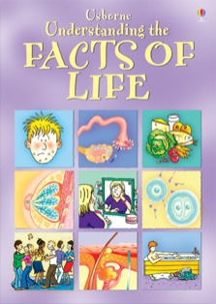 | Understanding the Facts Of Life  - Susan Meredith & Robyn Gee  Highly acclaimed guide with straightforward and reassuring information.  Describes exactly what happens at puberty, with informative sections on sex, contraception and sexually transmitted diseases, and advice on hygiene, exercise and healthy eating.  Also, Traces the development of a baby from conception to birth and first years of life, with practical information on how to help take care of a baby.
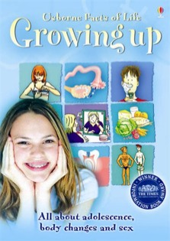 | Usborne Facts of Life: Growing Up  - Susan Meredith  A very approachable and reassuring account of exactly what happens in the body at puberty.  Includes informative sections on sex, contraception, sexually transmitted infections and drugs, as well as advice on healthy eating, exercise and hygiene.  Winner of the Times Educational Supplement Information Book Award.
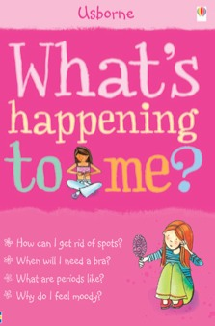 | What’s happening to me? (Girls)  - Susan Meredith  A sensitive, detailed and informative guide to female puberty, invaluable for young girls and parents alike, tackling key subjects from physical changes to buying their first bra.  Bright, stylish original colour illustrations and diagrams reveal everything young girls need to know about the changes they experience as they near puberty.  Written in a witty yet factual and clear style that makes this confusing and tricky subject approachable.  Includes basic details on what's happening to boys, too.
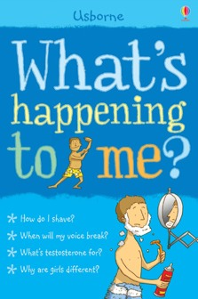 | What’s happening to me? (Boys)  - Susan Meredith  A sensitive, detailed and informative guide to male puberty, invaluable for young boys and parents alike, tackling key subjects from physical changes to emotional ones  Written in a witty yet factual and clear style that makes this confusing and tricky subject approachable.  Includes basic details on what's happening to girls, too.  Written in conjunction with medical and counselling experts
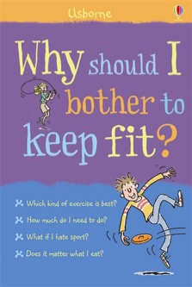 | Why Should I Bother To Keep Fit?  - Kate Knighton  You don’t like exercise? You’d never stay motivated? This book will change your ideas and attitude to getting fit.  All about how to maintain a healthy body through exercise and eating right.  Answers questions such as: What counts as exercise? What if I hate sport? and How can I get stronger?  Includes simple tips on healthy eating, games to play indoors when it’s raining and how to warm up and warm down properly.
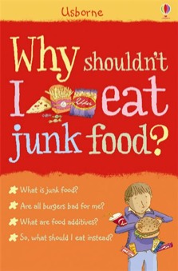 | Why Shouldn’t I eat Junk Food?  - Kate Knighton  A fun and informative guide to healthy eating which answers questions such as Why does junk food taste so good? What are food additives? What is processed food? and Can I still eat burgers?  Includes simple recipes for healthy snacks and burgers, ideas for taking more exercise and information on food labels, advertising and how food is grown.
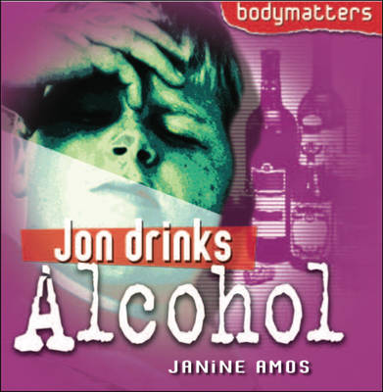 | Jon Drinks Alcohol (Bodymatters)  - Janine Amos  This hard-hitting series explains what happens to young people when they develop addictions or abuse their bodies in other ways  Jon is a 13 year old boy who begins to develop a drinking problem. His own experience and those of his father lead him to make the decision to stop drinking and look elsewhere for a solution to the difficulties he faces.
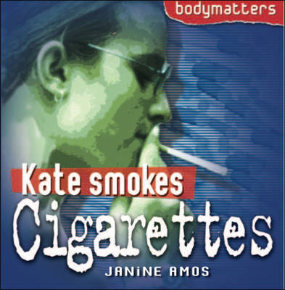 | Kate Smokes Cigarettes (Bodymatters)  - Janine Amos  This hard-hitting series explains what happens to young people when they develop addictions or abuse their bodies in other ways  Kate is a 13 year old girl who becomes addicted to smoking cigarettes. With the support of her friend Alice she eventually manages to give up the habit. But doing so proves harder than she thinks.
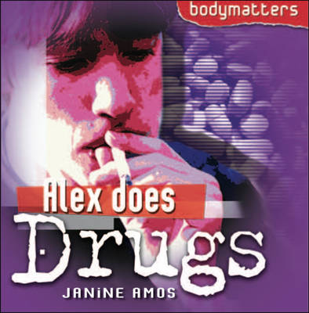 | Alex Does Drugs (Bodymatters)  - Janine Amos  This hard-hitting series explains what happens to young people when they develop addictions or abuse their bodies in other ways.  ‘Life is boring!’ decides Alex. He thinks drugs may bring him some excitement and an escape from his difficulties. For a while they seem to, but he finds that drug taking brings it’s own problems.
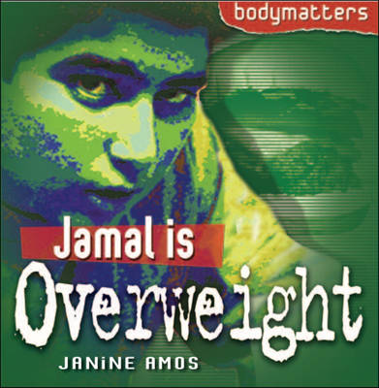 | Jamal is Overweight (Bodymatters)  - Janine Amos  This hard-hitting series explains what happens to young people when they develop addictions or abuse their bodies in other ways.  Jamal is fed up. He often feels tires and hardly ever gets picked for the football team at school. Eating all the time seems to make him feel better. Jamal eventually realizes he is overweight and decides to do something about it. But he’s not sure where to start…

