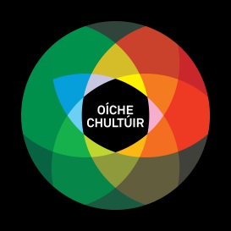

Registration Form for Culture Night (Irish language Events)

Name of Organisation
This will be published in Culture Night promotional material

Address
This will be published in Culture Night promotional material

Street

Town/City

Province

Postcode

Website
Please provide URL

GOOGLE MAPS LOCATION URL

Public phone number
This will be published in Culture Night promotional material

Contact person:
Name:

Email

Phone Mobile

Venue for the event:

Title and description of the event – for brochure
Max 50 words. Please provide essential information about the event.

Opening/closing hours on Culture Night:
Culture Night happens from 4pm to 11pm and support will not be provided for events happening outside of these hours.

Additional information about the event, for Culture Night website
Max 100 words

Details of the types of art form involved:
Please tick the appropriate box/es:

Arts and Crafts‎  Dance  Film  Heritage  Literature  Music 
Visual arts  Talk  Tour  Drama‎  Other: (Details, please)
‎
Events suitable for children/young people? Yes  No 

Venue facilities:
Wheelchair accessible Yes  No 
Café‎ Yes  No 
Bar Yes  No 
Restaurant Yes  No 

Upload Image – You need to provide a good image to promote your event – min 500kb, max 4mb!
You may upload up to three images to promote your event (png, .jpg, .jpeg).

Marketing Information
FACEBOOK page
URL, eg. http://www.facebook.com/culturenight

TWITTER
URL eg. http://twitter.com/CultureNight

INSTAGRAM
URL, eg. http://instagram.com/CultureNight/

Can Promotional Material be sent to the above address?
Yes  If not, please provide an alternative address:

Oíche Chultúir Support Fund:

If you wish to apply to the Oíche Chultúir Support Fund, please provide a breakdown of costs for the Night. Administration costs will not be covered. The maximum amount of funds provided for an event is €200 euro, except in exceptional circumstances.

Artists’ fees (details, please):

Activity/entertainment costs (details, please):

Venue hire (if this is not your own venue, or a venue which already receives state funding):

Equipment costs (sound/lighting etc.):

Other costs (details, please):

Total Costs:

Amount of funding sought:

Please send to liam@antoireachtas.ie by 5pm Friday 14 June 2019. If you do not receive an acknowledgement by return, please email us again to ensure we have received your form.

