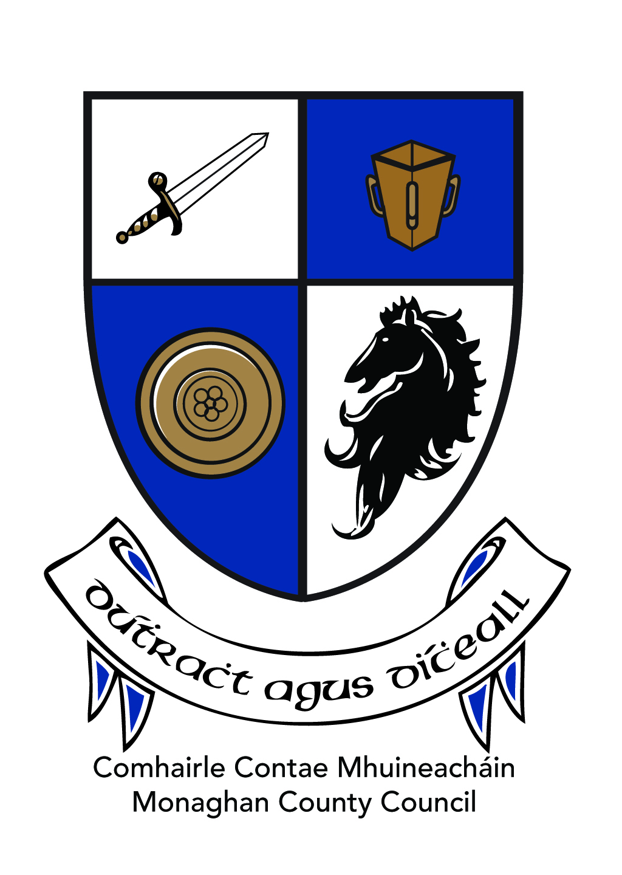

Comhairle Chontae Mhuineachain

Monaghan County Council

Awards Scheme 2023

The members of Monaghan County Council have initiated this Scheme in order to give due recognition to those individuals/groups in County Monaghan who, during 2023, have excelled in the areas of Sport, Arts/Culture, Youth, Community, Environment/Heritage. The Awards Scheme permits Monaghan County Council to publicly acknowledge these people for their contribution to our society and to show them that their efforts have not gone unnoticed.

Categories of Awards:

Nominations are invited from people/organisations based in County Monaghan in respect of one of the following categories:

Category A:

- Sports & Recreation

  - must have won a national title (first place/Gold) or
  - have represented Ireland at international level

Category B:

- Arts & Culture
- Youth
- Community
- Environment & Heritage

Conditions:

- Nominations must be submitted on official Nomination Form.
- An individual or group cannot nominate themselves or a family member.
- Elected members and members of the Oireachtas may not submit nominations.
- Staff of Monaghan County Council may not be nominated for an award.
- Residents of County Monaghan only may be nominated.
- Schools are not eligible to nominate students (unless they have been involved in a specific project where there has been a significant impact on their local community)
- Where a person receives an award under this Scheme, they cannot be nominated, in that activity, for the following two years.
- Persons or groups that have been afforded a Civic Reception will not be eligible for nomination for an Award under this Scheme.
- The decision of the Awards Committee is final.

Awards Committee:

An Awards Committee will review all nominations received and will select winners on the basis of the information submitted on the official Nomination Form. The Committee will consist of:-

- The Cathaoirleach of Monaghan County Council.
- The Chair of each of the four Strategic Policy Committees
- Others (to be agreed by the Council)

The closing date for nominations is 5.00p.m. on Friday, 16 February 2024.

