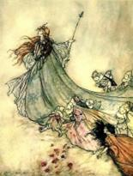
MONAGHAN TOWN ST PATRICK’S DAY PARADE
MONDAY 17th MARCH 2025 AT 3 P.M.

Community organisations, Clubs, Schools and Businesses are invited to enter floats/walking groups into the 2025 Parade
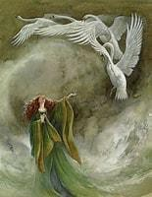 This Year’s THEME is 

“IRISH LEGENDS”
What/Who is your Irish Legend?
Fionn mac Cumhaill? The Children of Lir? Big Tom? Tommy Bowe? Leprechauns? Fairies?
Or is it something or someone else?
Bring your take on Irish Legends to the St. Patricks Day Parade 2025!
PARTICIPANTS SHOULD COMPLETE THIS ENTRY FORM AND RETURN TO:-
Monaghan St Patrick’s Day Festival Committee, C/o Monaghan Municipal District, The Glen, Monaghan. Enquiries Tel: 047 73777 or email monaghan@monaghancoco.ie
Name of community group, club,
school or business:
Description information of group, club, school, business
Contact Person:
Email Address:
Telephone:
Participation Type (Vehicle
Float/Walking Group/Band/etc):
Number of Vehicles:
Description of your Float/ Activity/ Entertainment for purposes of our Commentator and judging panel

