
Monaghan County Council Comhairle Contae Mhuineachain

Traffic Fine Appeal Form

ONLY APPEALS RECEIVED WITHIN 28 DAYS OF THE ISSUE DATE OF THE FIXED CHARGE NOTICE WILL BE ACCEPTED
Name:
Address:

Telephone:
Email:
Fine No: Fine Date: Reg No: I request the above Traffic Fine to be cancelled for the reason outlined hereunder:

Signed: Date:

Form to be returned by post to:
Municipal District of Monaghan, County Offices,
The Glen, Monaghan,H18 YT50
Ceantar Bardasach Mhuineachain Oifigi Contae
An Gleann
Muineachan ,H18 YT50

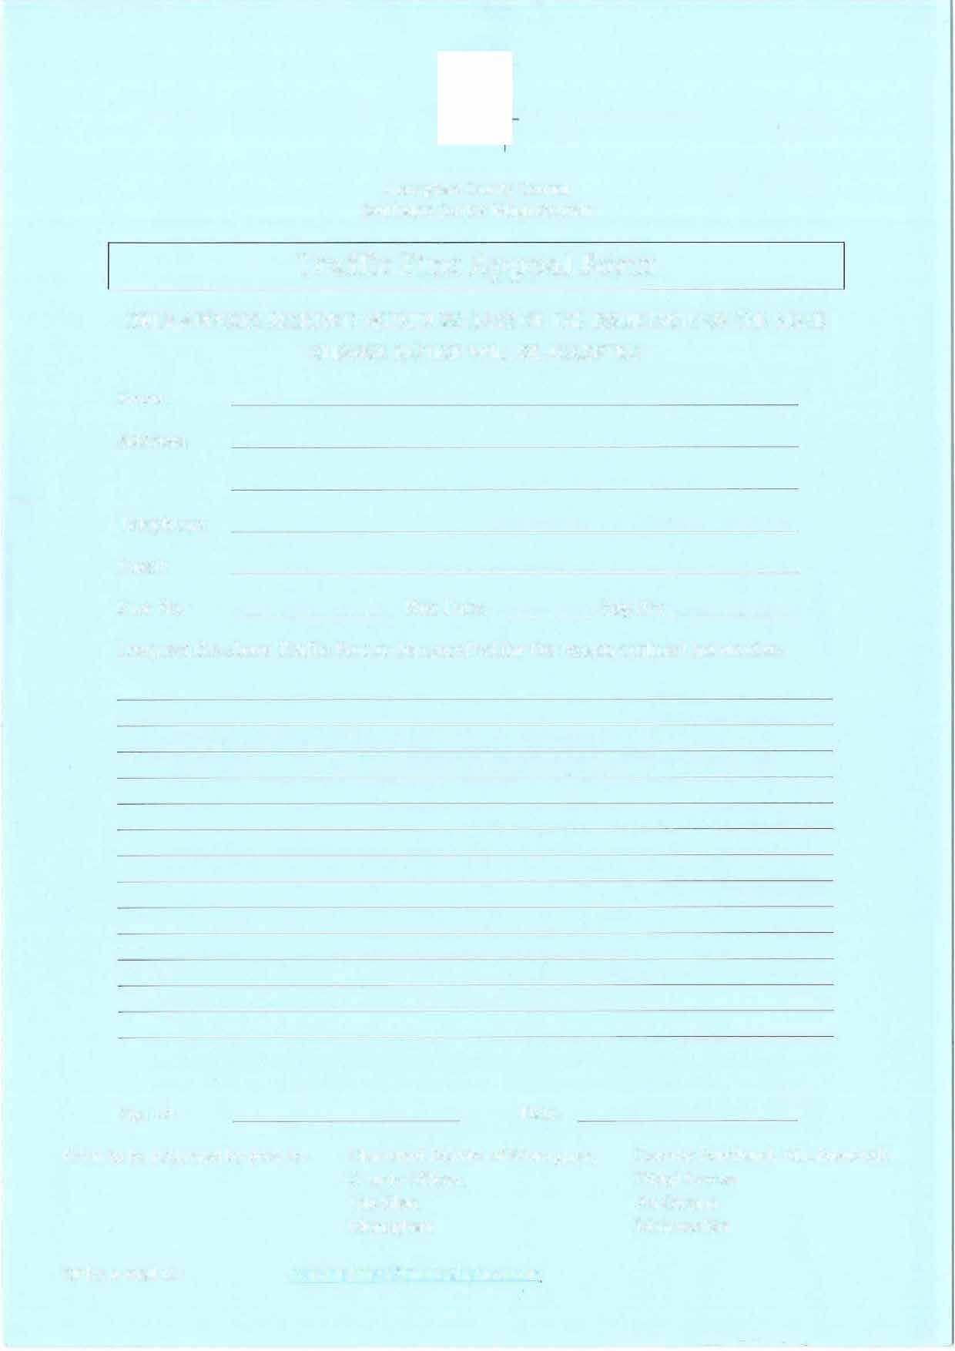
Or by e-mail to: parkingfines@monaghancoco.ie

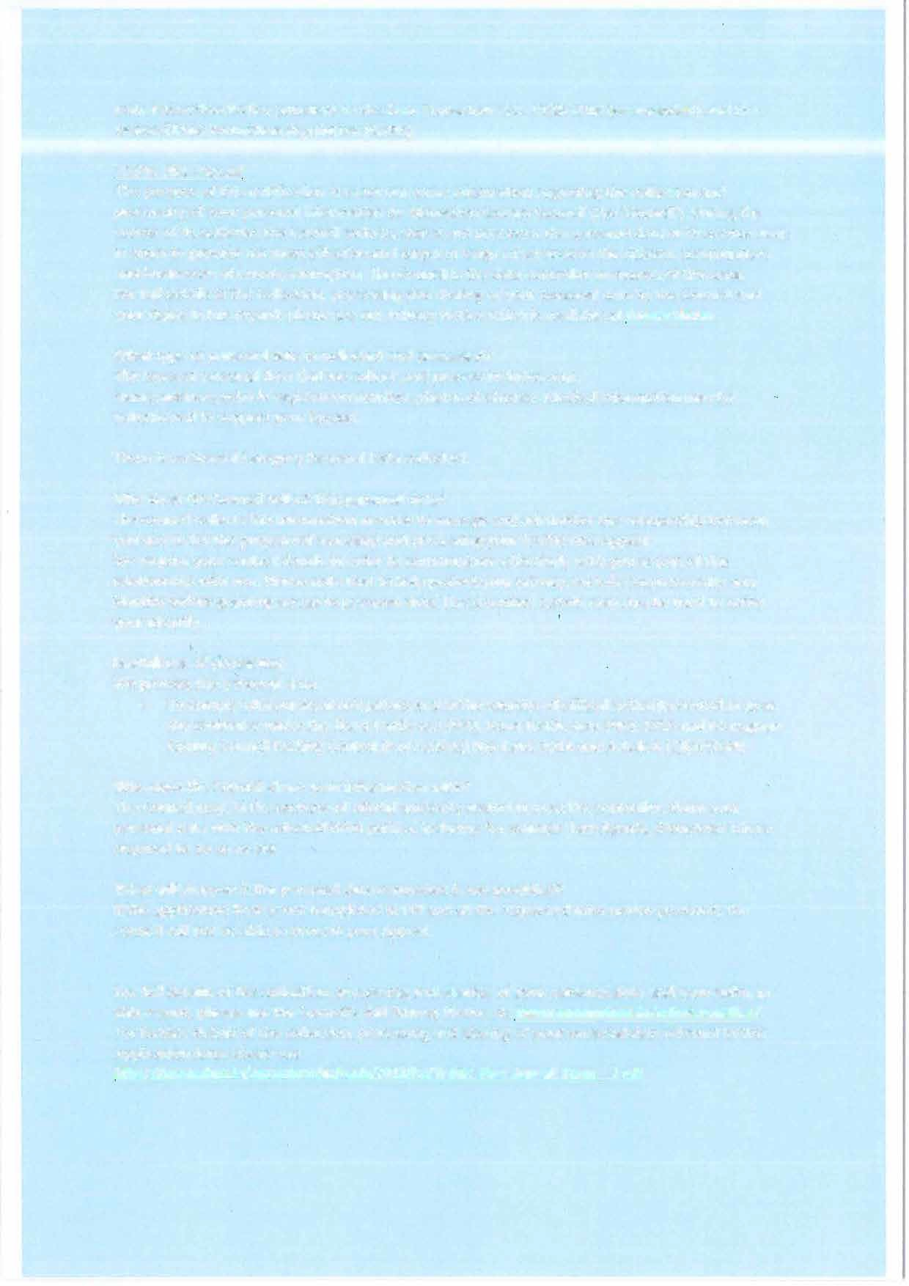
Data Protection Notice pursuant to the Data Protection Acts 1988-2018 (as amended) and the General Data Protection Regulation (GDPR)
Traffic Fine Appeal
The purpose of this notification is to set out some information regarding the collection and processing of your personal information by Monaghan County Council (the 'Council'). During the course of its activities the Council collects, stores and processes the personal data of its service users in order to provide the most effective and targeted range of services to the citizens, communities and businesses of County Monaghan. The Council is the data controller in respect of this data.
For full details of t"1e collection, processing and sharing of your personal data by the Council and your rights in this regard, please see our Privacy Notice which is available at Privacy Notice.

What type of personal data· is collected and processed?
The types of personal data that we collect, and process includes your:
Name, address, vehicle registration number, photos of offence. Medical information may be volunteered to support your Appeal.
There is no Special Category Personal Data collected.

Why does the Council collect this personal data?
The council collects this information in order to manage and administer the relationship between you and us for the purpose of assessing and processing your Traffic Fine Appeal.
We require your contact details in order to communicate effectively with you as part of this relationship with you. Please note that to help protect your privacy, we take steps to verify your identity before granting access to personal data. These contact details may also be �sed to verify your identify.

Lawfulness of processing
We process this personal data
- To comply with our legal obligations and in the exercise of official authority vested in us as the controller under the Road Traffic Act 1920, Road Traffic Acts 1961-2016 and Monaghan County Council Parking Control (Pay Parking) Bye-Laws 2014 and Article 6 (l)(e) GDPR

Who does the Council share your information with?
The Council may, in the exercise of official authority vested in us as the controller, share your personal data with the selected third parties, including for example Law Agents, Globetech where required to do so by law.

What will happen if the personal data requested is not provided?
If the application form is not completed in full and all the requested information provided, the council will not be able to process your Appeal.

For full details of the collection, processing and sharing of your personal data and your rights in
this regard, please see the Council's full Privacy Notice at: www.monaqhan.ie/privacy-notice/

